Learning Project – Music Online
Age Range: EYFS
Weekly Reading Tasks | Weekly Phonics Tasks
Monday- Monday- Have a look at the musical instruments. Talk about the different instruments, can you match the names to the correct one? Discuss the different ways of playing the instruments. Which instrument would you like to be able to play?  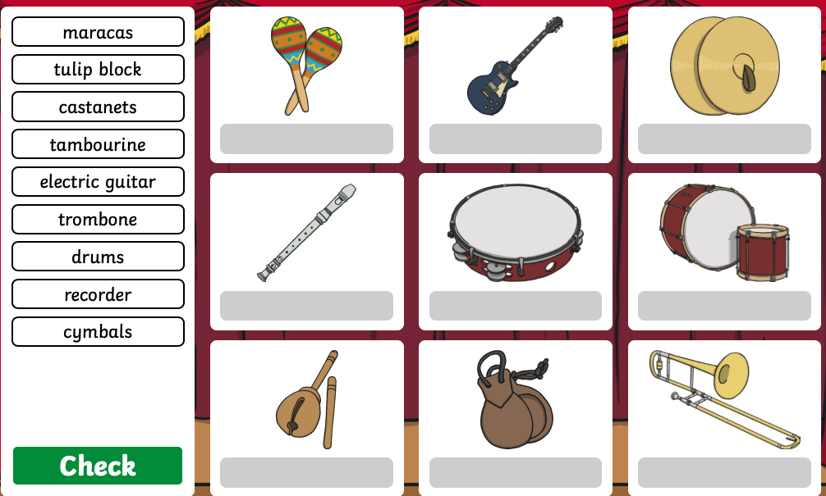  Practise reading the following words: any, their, where, two, small, love.  You will need the words for your phonic activity today. Write them on flash cards to practise reading at home. | Monday- Play Odd Sound Out. You could play a practical version of this using objects from around the house. Can your child identify which object doesn’t begin with the same sound? Play f, ff, ll, ss Read and Race!  Daily phonics - revisit the sounds your child is working on and blend words. This can be oral blending (Fred Talk) or written if appropriate.  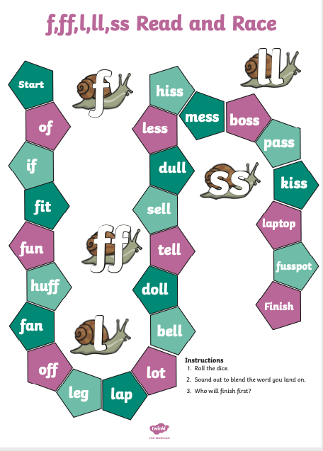
Tuesday- Read and sing the nursery rhymes below with your child. Which one is their favourite? Do any of the rhymes have the same rhythm? Can you think of rhymes that have the same rhythm?  Read keywords for this week (see Monday). | Tuesday- Choose a letter of the alphabet. How many instruments or sounds can your child name that begin with that sound?  Daily phonics - revisit the sounds your child is working on and blend words. This can be oral blending (Fred Talk) or written if appropriate.
Wednesday- Read together the story of Mr Big. Discuss with your child how Mr Big felt when the other animals didn’t want to be around him.  Read keywords for this week (see Monday). | Wednesday- Play Online Buried Treasure - Click on the sounds your child is learning. Can your child explain what the real word means?  Daily phonics - revisit the sounds your child is working on and blend words. This can be oral blending (Fred Talk) or written if appropriate.
Thursday- Write the questions onto cards for your child to read. Make yes / no cards for them to use to answer with after they have read the cards. Look at the question mark and discuss.  Read keywords for this week (see Monday).  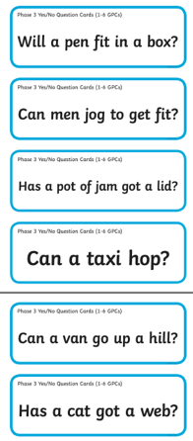  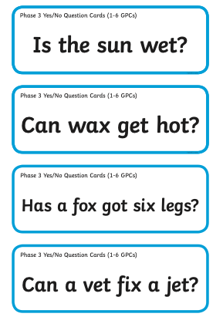 | Thursday- Ask your child to find a stick from the garden and explore making music around the house by tapping, hitting and scraping. You could ask them to make loud sounds, quiet sounds, sounds that are short and long.  Daily phonics - revisit the sounds your child is working on and blend words. This can be oral blending (Fred Talk) or written if appropriate.
Friday- We’re Going on a Bear Hunt Story sound effects- Read the story together and add in your own musical sound effects e.g. make swishy swashy sounds with fabric to go with ‘We’re Going on a Bear Hunt’. You can repeat this with as many stories as you like!  Read keywords for this week (see Monday). | Friday support your child to use the phonic knowledge to match the captions to the pictures.  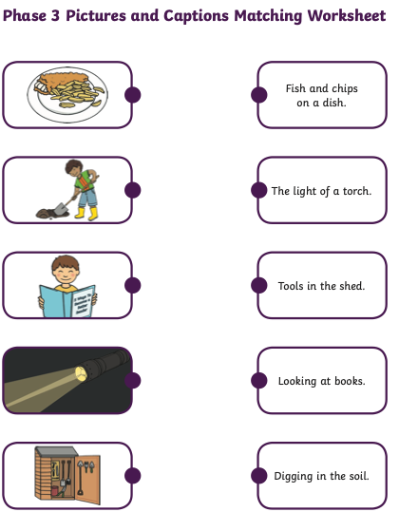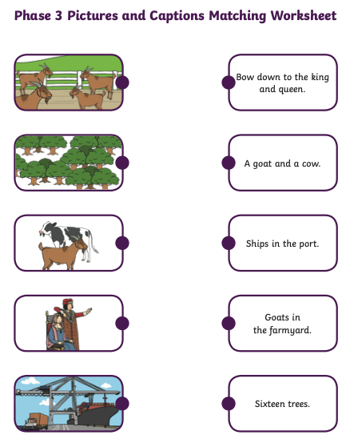  Daily phonics - revisit the sounds your child is working on and blend words. This can be oral blending (Fred Talk) or written if appropriate.
Weekly Writing Tasks | Weekly Maths Tasks- Shape
Monday- Ask your child to think about how some musical instruments are played, for example bang a drum, tap a tambourine, shake the maracas. Ask your child to write simple instructions to play their favourite instrument or instruments. Encourage your child should use their phonic knowledge to write words in ways which match their spoken sounds. | Monday- Take your child on a shape hunt. Look around the house and garden for different objects that have: 2D shapes – circle, square, triangle, rectangle (oblong)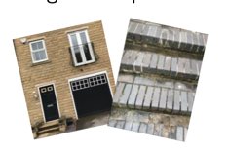Where can you see 2D shapes in the surface of everyday objects.  3D shapes – sphere, cube, cuboid, cylinder, pyramid. 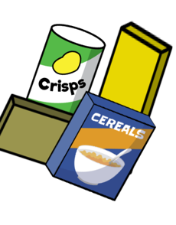  Make a collection of everyday objects in different shapes such as boxes, tunes balls etc Ask you child to choose one of the 3D shapes from your objects – ask them to tell you as many things as they can about this shape, can they find another shape like it? Can they find a different shape, how is it different?  White Rose Weekly Maths White Rose Maths -click for Summer Term guidance.
Tuesday- Your child can draw a picture of the events from their favourite Nursery rhyme. Ask your child to write out the words to the nursery rhyme. Remember capital letters, finger spaces & full stops. Your child should use their phonic knowledge to write words in ways which match their spoken sounds. The simple sentences which can be read by themselves and others. You should expect some words to be spelt correctly and others should be phonetically plausible. | Tuesday- Sing these shape songs together: 2D shape song and the 3D shape song. Then play the Turtle Diary online game.  White Rose Weekly Maths White Rose Maths -click for Summer Term guidance.
Wednesday- Think about Mr Big. How did he feel after he had joined the band?  Re listen to the story. Write a list of emotion words to explain how Mr Big would have been feeling. | Wednesday- Can your child draw around objects to create 2D shapes? Ask your child to name the shapes they have drawn. Can they cut the shapes out to make a 2D shape picture i.e. a house, rocket, robot?  White Rose Weekly Maths White Rose Maths -click for Summer Term guidance.
Thursday- Following on from the reading activity today ask your child to write three of their own yes / no questions. Remember to encourage your child to use their phonic knowledge to sound out their question as they write it down. | Thursday Look around your home or when out for a walk items to help you to talk about tall and short, taller and shorter, tallest and shortest (perhaps you have some spades to compare). Items that are longer and shorter, longest and shortest (straws, rope, a hose pipe etc) Near and far or nearest or furthest etc.  White Rose Weekly Maths White Rose Maths -click for Summer Term guidance.
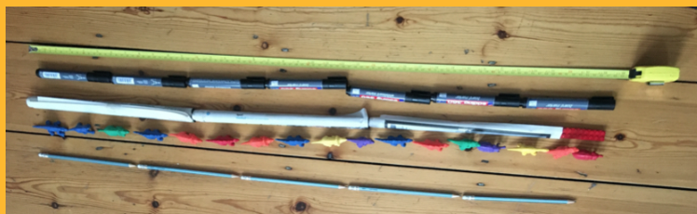  Friday- Listen to the story of We’re Going on a Bear Hunt. Draw a picture of the bear together and label it – One shiny wet nose, two big furry ears, two big googly eyes! | Friday- How long are you? Ask your child to lie on the floor, the adult ‘measures’ the child by putting a marker by the head and the feet, then stretching a piece of tape as long as the child. Ask your child how many pens will match this, carefully place them end to end, making sure they are straight, with no gaps or overlaps. Repeat with other things of uniform length, some long, some short (such as rolled up sheets of newspaper, spoons, buttons, Lego or Duplo bricks) to make several ‘trails’ of equal length and compare results.  Encourage Mathematical thinking and reasoning: Describing  What do you notice about using the pens and paper rolls? How many pens does it take to match the tape? You are 20 pens tall! How many paper rolls tall are you? You are 3 and a bit rolls long / not quite 3 rolls long.  Reasoning  I wonder what will happen if we measure with Lego bricks? Why do you think there will be more? There are some gaps between the dinosaurs – do you think that matters? Does it matter if they are not the same length?  Opening Out  Which did you use the most of? Which needed the smallest number? You are three and a bit rolls long – what do you think we could use to measure the extra bit – little Lego bricks? How many pends tall do you think your frown up will be? What other things are the same height as you? Which are shorter or taller? How tall are you with the measuring tape? What numbers can you see? Are you more or less than a metre tall? How many footsteps tall are you? (make sure you walk heel to toe and in a straight line)

Learning Project - to be done throughout the week
The project this week aims to provide opportunities for your child to learn more about music. Learning may focus on famous musicians, listening to and performing music and exploring a range of music genres and instruments.

Drummers Drumming
- Using pots, pans and baking trays from the kitchen lay out your own ‘drum kit’. Allow your child to explore by banging and tapping the pans to see the different sounds they make. Extend this activity by tapping out a rhythm and asking your child to listen to it then repeat it. You could make this more difficult by adding in a blindfold, so they have to rely on the sound to identify which pot or pan they need to hit to copy.

Make your own Music
- Your child could create a guitar using a plastic tub with elastic bands wrapped around it. Post a picture of your musical instrument onto your child’s Tapestry account. Can your child draw instructions on how to make a guitar for somebody else to follow?

Play ‘What’s that Sound?’
- Game 1- Hum a song to your child that they are likely to know. Can they guess which song it is from the tune alone? Take it in turns to hum out a tune.
- Game 2- Go into a room of the house while your child listens outside of the door. Make a sound or play a rhythm out on an item in the room e.g. tapping on the table. Open the door and ask your child to find what you used to make the sound.

A Family Music Show
- Ask each member of the family to prepare a song and then put on a singing performance. You could select someone to be the judge or ask a family member to watch on a video call and decide on the winner.

Discovering Different Eras
1920’s | 1930’s | 1940’s | 1950’s | 1960’s | 1970’s | 1980’s
- Click on the links above and listen to a sample. Which era did your child find most enjoyable to listen to? Can they dance in the same style?
STEM Learning Opportunities #sciencefromhome
Making Instruments – Make Sound Shakers
- Collect some different containers with lids, make sure you cannot see through them. The small plastic water bottles work really well. Put different materials in the containers. (Stones, rice, sugar, paper clips etc.)
- How many shakers can you make? Do they all sound the same? Can you make a shaker that is difficult to recognise? Can you make loud and quiet sounds with them?
- For more ideas take a look at the full resources here.
Wellness
Help your child find a quiet space where they can lay down comfortably. Today we will use music as a tool to help us relax.
Explain to your child that you will play some music for them to listen to as they lay still and focus on taking big, slow breaths. You could help them to relax further by guiding them first to relax their toes, then the rest of their legs, now relax the tummy and the chest, followed by arms and hands. Finally relax every part of the face. Now the entire body is completely relaxed. Your child can stay here, just listening and relaxing, for as long as they feel comfortable.
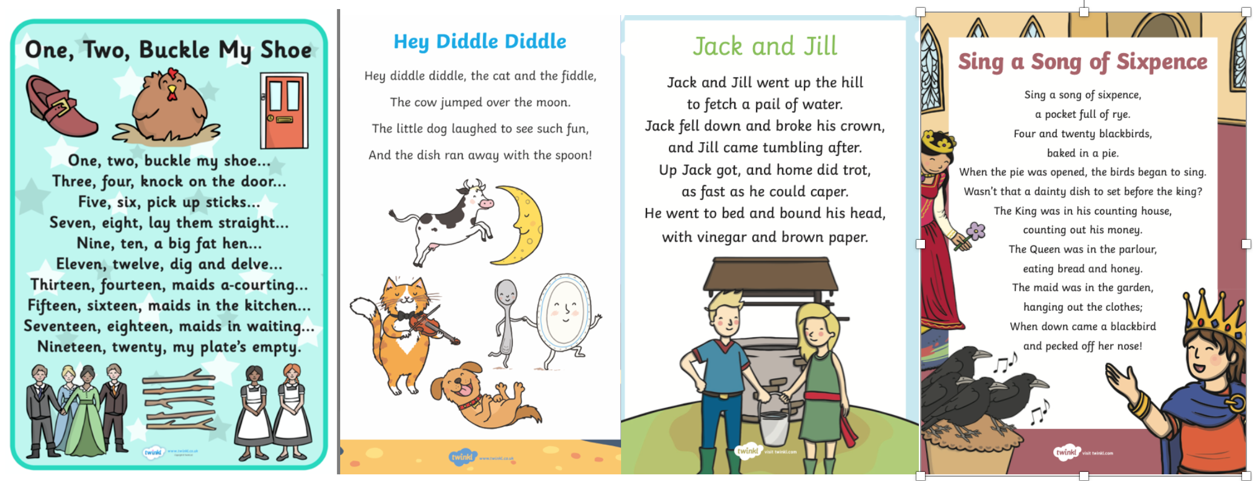
#TheLearningProjects
in collaboration with
