Learning Project WEEK 7 – Celebrations-Online
Age Range: Y3/4
Weekly Maths Tasks (Aim to do 1 per day) | Weekly Reading Tasks (Aim to do 1 per day)
- Working on Times Table Rockstars - your child will have an individual login to access this  - If your child works on ‘Numbots’  in school they can access this with the same login.  - Play this game to support your addition and subtraction skills.  - Y3 amounts up to and including 3 digits  - Y4 – amounts up and including 4 digits.  - Practise giving change through this game  - You may want to practise solving them yourself first to show your workings.  - Practise telling the time through playing this game to the nearest 1 minute.  - Then practise solving problems linked to durations of time by playing this game  - Y3 – Practise finding fractions of amounts by playing this game. See if you can get up to levels 7 and 8 for trickier challenges.  - Y4 – Practise placing decimals on a number line by playing this game  - Daily Fluency Activities can also be reached from this website ( Week 2)  Daily Maths Lesson & BBC bitesize  - The above site also has daily Maths lessons which can be accessed online.  - These are available for Y3 and for Y4. | - You could share a story together. This could be a chapter book where you read and discuss a chapter a day.  - Listen to your child read and let them discuss what they have read. Encourage them to read with expression and intonation.  - Watch Newsround and discuss what is happening in the wider world.  - Get your child to read a book on Oxford Owl, discuss what your child enjoyed about the book. (undertake an AR quiz)  - Get your child to read a book on Active learn and complete the activities. These focus on comprehension skills.  - Explore new vocabulary you find when reading. What are the origins of this word? Can it be modified? Can you find any synonyms or antonyms for your new word?  - With your child, look in magazines, newspapers and books for new vocabulary they are unfamiliar with. They could use a highlighter to highlight in magazines and newspapers
Weekly Spelling Tasks (Aim to do 1 per day) | Weekly Writing Tasks (Aim to do 1 per day)
- Practise the Year 3/4 for Common Exception words.  - Practise your spelling on Spelling Shed  - Practise your spelling on Spelling Frame  - Choose 5 Common Exception words. Write a synonym, antonyms, the meaning and an example of how to use the word in a sentence. Can the word be modified?  - Choose 5 Common Exception words and practise spelling them using words within words. Write the word and find smaller words within them, e.g. spelling = line, gel, in, etc…. | - Write a postcard to a family member recounting a celebration that has just taken place.  - Write a set of instructions for ‘How to play the new game?’ Remember to include a list of things they will need. Don’t forget to include headings and subheadings. Then write their set of instructions, remember to include imperative verbs. (Verbs that command you to do something). Think about the key rules!  - Write a non-chronological report about a religious festival they have found out about.  - Write a scary story that would be great to read aloud on Halloween. Use the images on Spooky to give them some inspiration.  - Design a card celebrating a religious celebration, remember to include a poem/verse for inside. You could make either an Eid, Easter, Diwali card etc….See links below- understanding others and appreciating differences  - Take part in a writing master class.
Learning Project - to be done throughout the week
This project this week aims to provide opportunities for your child to learn more about celebrations. Learning may focus and different types of celebrations that take place and who may celebrate them. It could look at how people celebrate different events differently in other parts of the world.

- Let’s Wonder:

How are birthdays celebrated around the world? India China America Africa etc.. maybe
there's a country they would like to find out about. Create fact files to show the
similarities and differences between them.
- Let’s Create:

Create a board game that focuses on celebrations. Think about what they can learn from it? Think about how to play the game. Is it going to be a game like Monopoly or Snakes and ladders? Are they going to need a dice? Cards? Characters? etc….

- Be Active:
- Jo Wicks-9.00 daily

Why not play a game of hopscotch? Can’t find any chalk? Use a stone from the garden. Raining? Build an indoor den and have an imaginary celebration with their toys.
Recommendation at least 2 hours of exercise a week.

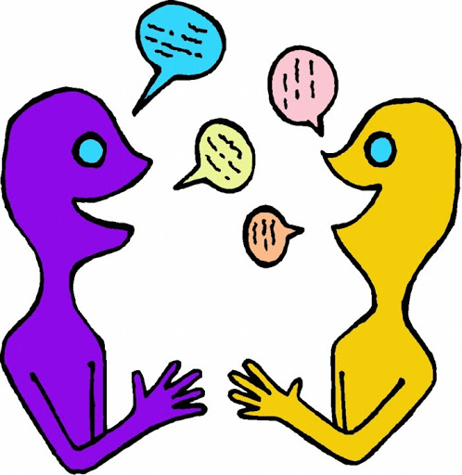
- Time to Talk:

Look through old photos of previous celebrations you and your family have taken part in. What can they remember happened? Why do they and their families celebrate the way they do?

- Understanding Others and Appreciating differences:

How many different types of celebrations are there? Who celebrates Christmas? St Patricks? St George? St David? Easter? Eid? Diwali? Chinese New Year? and how?
Which celebrations have they taken part in? What usually happens?

Mindfulness – Balance a pebble/ shell/ toy
Encouraging your child to have some focused mindfulness time is a great way to help them cope with any difficult feelings. Mindfulness activities also contribute to brain health and general wellbeing. Your child can start with short amounts of time and build up as they develop the ability to be still, calm and quiet.

For this activity you need something that you will be able to balance on top of your stomach in a lying down position. You could use a pebble / shell / soft toy. This activity will help your body and brain to feel relaxed and calm. Try to find a quiet space where you can lie down for a few minutes without any interruptions.
Lie down on your back, with your legs straight and then place the item you chose onto your stomach. Relax your arms down by your sides. Close your eyes and concentrate on your breathing. Can you feel your chest moving up and down? See if you can make your breathing slower and deeper, so that your stomach starts to rise and fall too. Can you feel the pebble / object moving up and down as you breathe? Keep focusing on your breathing and the feeling of your stomach rising and falling. Aim to keep going for about 3 to 4 minutes.
Additional learning resources parents may wish to engage with
Classroom Secrets Learning Packs - These packs are split into different year groups and include activities linked to reading, writing, maths and practical ideas you can do around the home.
Twinkl - to access these resources click on the link and sign up using your own email address and creating your own password. Use the offer code UKTWINKLHELPS.
Headteacherchat - This is a blog that has links to various learning platforms. Lots of these are free to access.
#TheLearningProjects

