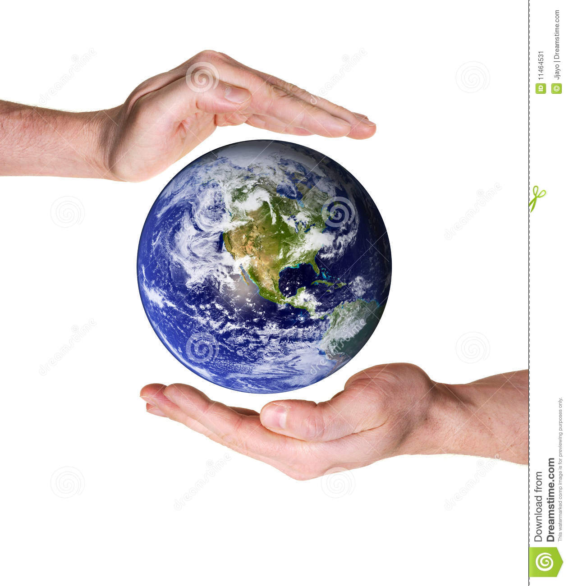

**Science**

Dissolving; and how to recover a substance from a solution. Separation of materials.

Describing the water cycle including evaporation and condensation.

**World of Wonder**

**Class 2**

**Spring 2019**

**Design – Construction (wood)**

Designing and building a temple based on Shang Dynasty style.

**Religious Education**

Faiths: Christian, Islam, Hindu

Christianity in Cornwall. Methodism. Prayer book rebellion.

**Art**

Drawing skills.

Fabric work.

**Geography**

Learning about China. Comparing Mexico and China. Locating rivers and mountains. UK geography.

**Music**

Composing, evaluating, improving and performing – work linked to ‘World of Wonder’ and the water cycle.

**Modern Language**

Speaking French -describing people, places and objects.

**Physical Education**

Swimming

dance

**Computing**

Planning and programming on screen animations. Ongoing online safety work.

**History – The Shang Dynasty**

Timelines, using artefacts to gather information; lives of children and rich/poor. Comparing two periods.

**English**

**Text**: Danny the Champion of the World.

**Writing :** Instructions, poetry and playscripts.

**SPAG:** Paragraphing. Root words, prefixes and suffixes. Pronouns, nouns and adverbials.

**Reading comprehension:** Inferring meaning. Identifying themes and predicting. Preparing and performing poems.

**Spelling:** Word lists from Shakespeare and more spelling Y4 – list 21, 22; Y5; list 27, 28

**PSHE**

Protecting the environment.

Living in the community

**Maths – Mastery**

Multiplication and division.

Fractions, decimals and percentages.

Statistics.

Geometry – position and direction.