Learning Project WEEK 6- Food online
Age Range: EYFS
Weekly Maths Tasks
Watch a Numberblocks clip each day at: BBC or CBeebies. Use this guide here to give you ideas on what to do with your children whilst watching an episode.

Working on Numbots - your child will have an individual login to access this.

Play the Numberblocks add and subtract game.

Explore weighing and measuring food on the kitchen scales. Ask, what happens as you place more on the scales?

Look for numerals on packaging you find around the house. Can your child recognise the numerals and count out a matching amount?

White Rose Weekly Maths White Rose Maths -click for spring term guidance.
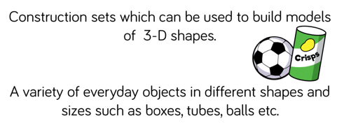
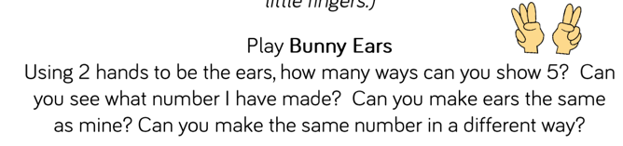

Weekly Phonics Tasks (Aim to do 1 per day) | Weekly Reading Tasks (Aim to do 1 per day)
Sing Nursery Rhymes and songs together. Add in actions and change the words. Can children think of different rhyming words to add in? Repeat old favourites and learn new rhymes. You can find an A-Z of Nursery Rhymes.  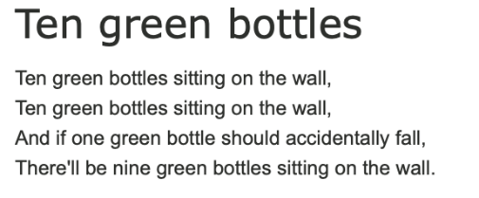  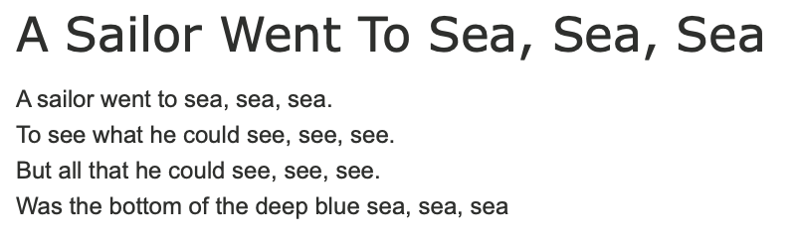  Daily phonics - Practice the sounds your child is working on and blend words. This can be oral blending (e.g. Fred Talk c-a-t) or written if appropriate. Please visit https://www.ruthmiskin.com/en/find-out-more/parents/ for more information and support.  Interactive games.  Pour flour, rice or lentils into a shallow tray or plate. Show your child a letter, digraph, trigraph or tricky word and ask them to ‘write it’ in the food using their finger.  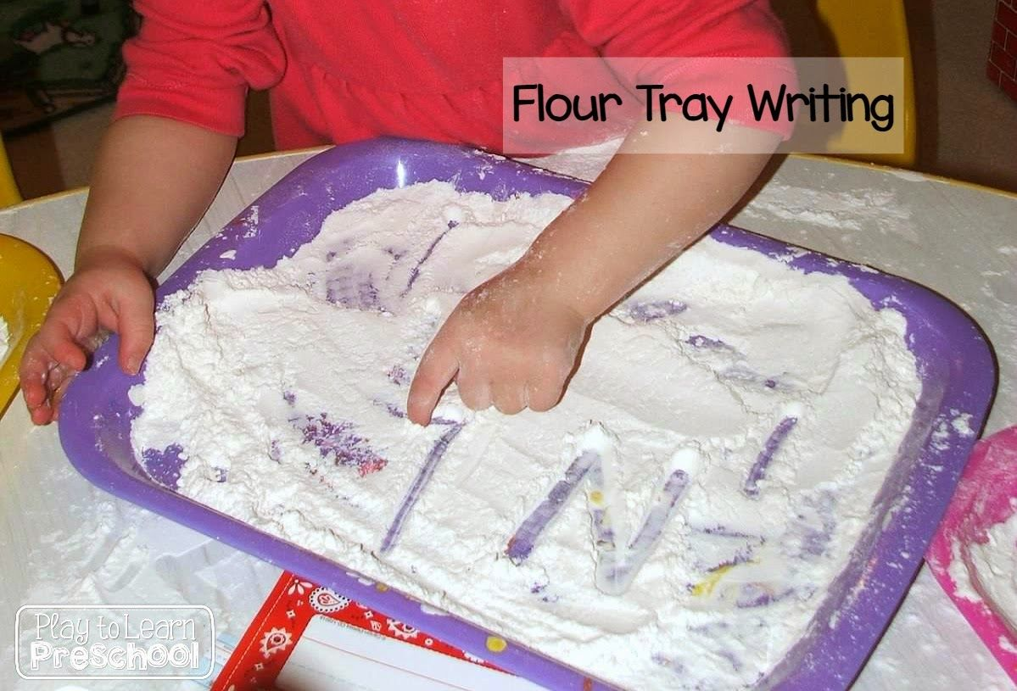 | Read a variety of books at home. Favourites can be repeated. Hearing the patterns of language in a story will support your child’s language development.  Reception age children: Children to read to parents daily. Visit Oxford Owl for free eBooks that link to your child’s book band. You can create a free account. Complete the linked Play activities for each book.  With your child, look in magazines, newspapers and books for the tricky words they are currently learning. They could use a highlighter to highlight in magazines and newspapers.  Look at recipe books and food magazines. Encourage your child to use their phonics knowledge to decode the ingredients list. Select a recipe and make this together. Encourage your child to read the labels on packaging to figure out which ingredient it is.
 | Weekly Writing Tasks (Aim to do 1 per day)
Practice name writing. Can they write their first name? Middle name? Surname?

Practice forming the letters of the alphabet. Follow your school’s script.

Ask your child to write out the tricky words (red words) they are working on at the moment on pieces of paper and turn them into a game.

Using recipes from books as a guide, ask your child to create their own recipe for their dream meal. They could draw out the ingredients and label them and draw the finished meal. Some children may be able to write a few short sentences as instructions.

Look at a range of different packages found around the kitchen. Discuss with your child what makes it stand out to a customer. Support them to design a package for a treat of their choice.

Make a food diary see learning project below.
Learning Project - to be done throughout the week
The project this week aims to provide opportunities for your child to learn more food. Learning may focus on where different foods originate from, what makes a healthy meal, opportunities to cook etc.
- Healthy/ Unhealthy-
  - Provide your child with a selection of items from your kitchen cupboards. Can they sort them into things that are healthy and unhealthy? Discuss why the food is good for you or bad for you. Look at the Eatwell plate to help figure out which foods they should eat a lot of or not very much of.

- Discuss how exercise is an important part of staying healthy. Watch and complete a 10 minute shake up.

- 5 a day-
  - Support your child to create a food diary to record how many pieces of fruit and vegetables they eat in a day. They could write these using their phonics knowledge or draw a picture of each item.

- Create a collage-
  - Ask your child to draw out a number of fruits or vegetables, large enough to fill a piece of A4 paper. Provide them with a selection of colourful packaging. Can they cut out and collage on to their picture to

- Play shops-
  - Using toy food or old packaging, set up a food shop for your child to act out being the shopkeeper and customer. You could introduce coins to support their developing knowledge of money. Give them a notepad to use as a shopping list to encourage in the moment writing.

- Potato/ Vegetable Printing-
  - Using a selection of vegetables available in your kitchen, support your child to print and explore the shapes and patterns created:
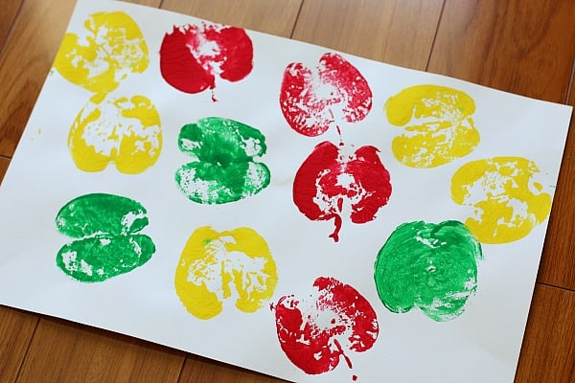
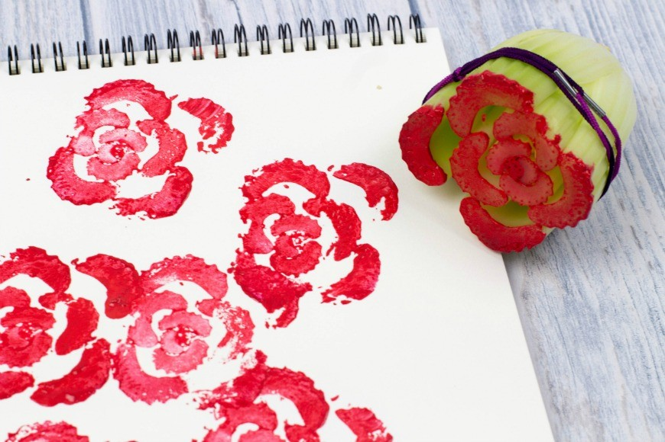
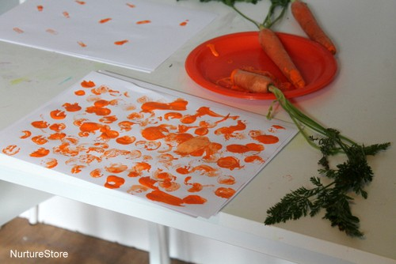

- Make cornflour gloop-
  - Mix cornflour with a small amount of water in a mixing bowl. It will make a slimy, stretchy mixture. Allow your child to explore the change of texture from wet to dry and the texture of the gloop.
Additional learning resources parents may wish to engage with
Classroom Secrets Learning Packs - These packs are split into different year groups and include activities linked to reading, writing, maths and practical ideas you can do around the home.
Twinkl - to access these resources click on the link and sign up using your own email address and creating your own password. Use the offer code UKTWINKLHELPS.
Headteacherchat - This is a blog that has links to various learning platforms. Lots of these are free to access.
#TheLearningProjects

