W/C 18.05.2020: Learning Project - Under the Sea
Online
Age Range: KS1
Weekly Reading Tasks | Weekly Phonics Tasks
Monday- Encourage your child to learn the rhyme ‘A Sailor went to Sea, Sea, Sea’. Click here for a video of the rhyme and lyrics. Can your child perform this rhyme by heart? | Monday- Go on a sound hunt with your child around the house/garden. They can list all of the items they can find containing the ‘ea’ sound. They may identify objects that contain an alternative way of spelling the ‘ea’ sound such as ee/y/e.  Daily Phonics- Practice the sounds your child is working on and blend words. This can be oral blending (e.g. Fred Talk sh-e-ll) or written if appropriate.
Tuesday- Task your child with building an ‘Under the Sea’ themed reading den. Can they find some sea-themed books to cosy up with and share in there? | Tuesday- Can your child list words that they associate with the sea? Following this, ask your child to identify words that rhyme with these.  Spellings:  Year 1- when, where, which, wheel, while  Year 2- pretty, beautiful, after, fast, last, past, father  Daily Phonics – See Monday
Wednesday- Ask your child to make a sea-themed bookmark. They could take inspiration from ‘Sharing a Shell’ or ‘The Snail and the Whale’. | Wednesday- Encourage your child to practise spelling the months of the year and then use them in a sentence.  Daily Phonics – See Monday
Thursday- Your child could read a story/poem/nursery rhyme to another family member. This could be to a younger sibling before bedtime or they may wish to Facetime an elderly relative (with adult supervision of course). | Thursday- Your child could visit Phonics Play and play Buried Treasure.  Daily Phonics – See Monday
Friday- Read along with ‘There’s a Hole in the Bottom of the Sea’ or listen to ‘How the Whale got his Throat’. Ask your child to retell one story by drawing a comic strip of the events. | Friday- Ask your child to write the alphabet using capital letters. Challenge your child to write the lowercase letters too.  Daily Phonics – See Monday
Weekly Writing Tasks | Weekly Maths Tasks- Time  Choose a task or tasks from each day. These are to be used flexibly
Monday- Visit a desert island here. Ask your child to write a message in a bottle. What can they see, hear, feel, taste and smell? Why not roll the message up and pop it in a plastic bottle for the reading den? | Monday- Write the days of the week on paper and cut them up into cards. Take turns turning over the cards. If, when you turn the card, you have a day that is before or after the day shown you can say snap.  White Rose/ Bitesize Maths online daily maths lessons.  CODE Maths Fluency Activities – Week 3
Tuesday- Task your child with planning the perfect beach trip. Ask them to draw and label all of the things that they would pack including a picnic. Who would they take? What games would they play? How much time would they spend in the sea? | Tuesday- Using a clock in your house practise telling the time with your child to the nearest hour, half hour, 15-minute intervals extending to 5 minutes intervals for Y2. With your child, list different activities/chores they have to do throughout the day. Write down the times which they start each activity Can they order them after making the list? Can your child sort them into the times of day each thing happens in (e.g. morning, afternoon, night etc)?  White Rose/ Bitesize Maths online daily maths lessons.  CODE Maths Fluency Activities – Week 3
Wednesday- Speak to your child about all of the things that make them happy or all of the things that they’re grateful for. Ask them to record these in a list. | Wednesday- With your child, list different activities/chores they have to do throughout the day. Write down the times which they start each activity Can they order them after making the list? Can your child sort them into the times of day each thing happens in (e.g. morning, afternoon, night etc)?  White Rose/ Bitesize Maths online daily maths lessons.  CODE Maths Fluency Activities – Week 3
Thursday- Help your child to create a fact file about the endangered Sea Turtle. Can they find out about its appearance, its diet and its habitat? This link may help. Following this, your child could draw a detailed sketch of the Sea Turtle. | Thursday- Using your list from Wed explore how long each activity lasted using the terms hours and minutes. To extend this further why not look at the start and end times of your favourite programmes? For this you may also want to draw a clock stating what time it started and another stating what time it finished. Following this state how long the programme or activity lasted.  White Rose/ Bitesize Maths online daily maths lessons.  CODE Maths Fluency Activities – Week 3
Friday- Visit the Literacy Shed for this wonderful resource on The Lighthouse. Or, your child could design a beach safety poster. What tips would they give beach- goers for staying safe at the seaside? | Friday (theme)- Ask your child to survey the family about their favourite sea creature (choose from 5). Represent the results using a tally chart or a pictogram. Which sea creature was the most popular? Which was the least popular?  White Rose/ Bitesize Maths online daily maths lessons.  CODE Maths Fluency Activities – Week 3

Learning Project - to be done throughout the week
The project this week aims to provide opportunities for your child to learn more about life in and around the sea. Learning may focus on the strange and wonderful creatures and plants that occupy our oceans, their habitats and how human beings affect this environment.

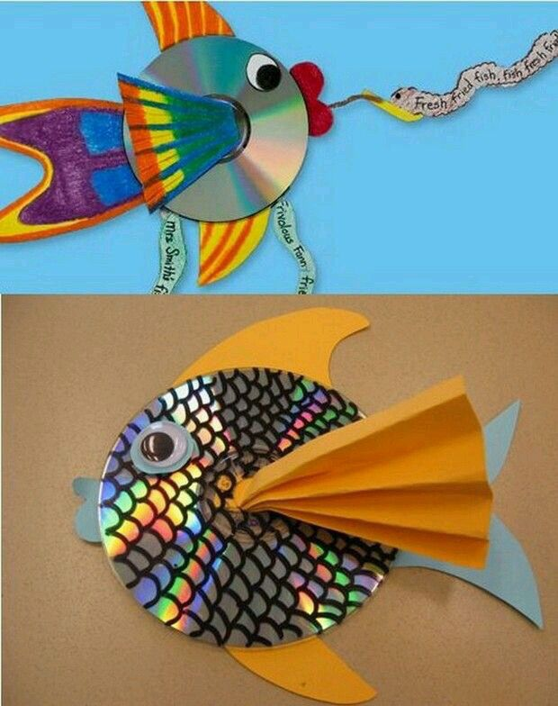
- Top Trumps/Guess Who?- Ask your child to write fact cards about animals from under the sea. They can use books or websites to find out about the appearance, habitat and diet of each creature. After this, play a game of ‘Top trumps’ or ‘Guess Who?’ using the cards and yes/no questions.

- Junk Modelling- Using junk or recycling materials from around the home, ask your child to design and make a Sea Turtle. Your child may wish to make another sea creature after this. Share your creations with us by sending a photo to your school secretary email address.

- Put Your Goggles On- Your child can visit this website and watch a live stream of a tropical reef. Whilst watching, ask them to sketch some of the animals that they can see. You can pause the picture. Remind them to look at the shapes and patterns on each creature and to include these in their sketches.

- How do Humans Affect the Sea? - Is your child aware of all of the ways that humans affect the sea and the living things within it? Talk about and investigate the impact that human beings have on the sea. Think about fishing, transport and pollution. Create a poster or information report.

- The Oceans of the World- Using an atlas or the web (with an adult) ask your child to identify the world’s oceans. Year 1 children may need some support with this. Can they find out what animals live in each ocean? This game allows your child to practise naming and locating the oceans.

- Beach Safety https://rnli.org/safety/beach-safety and https://rnli.org/youth-education/education-resources/activity-sheets-and-posters
As we are approaching summer please use this excellent site from the RNLI to discuss beach safety.

Mindfulness
Help your child to choose a piece of instrumental music that they find relaxing. Have them lie down on their back with their eyes closed and both hands on top of their tummy. Ask them to close their eyes and concentrate on their breathing. Can they breathe deep and slow so that they feel their tummy moving up and down under their hands? Ask them to stay like this as the music plays. Just breathing and listening, nice and still. Aim for around three minutes to start with and increase to 5 minutes later in the week.

STEM Learning Opportunities #sciencefromhome
Unplugged Coding
- Watch this video for a description of coding but complete the activities below.
- Create a simple under the sea obstacle course or draw an obstacle course on a piece of paper. Write simple code to guide the submarine around the obstacles found under the sea. E.g. Rocks, shipwrecks, sleeping octopus. E.g. →→↓→→↑→ etc.
- How would you instruct a robot to move in different shapes? Square, rectangle etc
Additional learning resources parents may wish to engage with
- Visit this BBC website for more sea themed music and learning ideas.
- There are some lovely games and ideas from the Royal National Lifeboat Institution here.
- Maths
- White Rose/ Bitesize Maths online daily maths lessons.
- CODE Maths Fluency Activities – Week 3
- Numbots. Your child can access this programme with their school login.
- IXL- Click here for Year 1 or here for Year 2 . There are interactive games to play and guides for parents.

- Y1 Talk for Writing Home-school Booklets and Y2 are an excellent resource to support your child’s speaking and listening, reading and writing skills.
The Learning Projects are based on the National Curriculum expectations for the key stage which your child is in. It may be that your child finds the tasks set within the Learning Project for their year group too simple. If this is the case, then we suggest that your child accesses the Learning Projects which are set for the key stage above. Equally, if the projects are too challenging, then we advise that your child accesses the projects for the key stage below.
If your child requires more of a challenge, or you believe that there are some gaps in their learning then Century Tech is a fantastic resource that is currently free for home learning. The app is designed to address gaps and misconceptions, provide challenge and enables children to retain new knowledge. It uses artificial intelligence to tailor the learning to your child’s needs. Sign up here.
#TheLearningProjects
in collaboration with
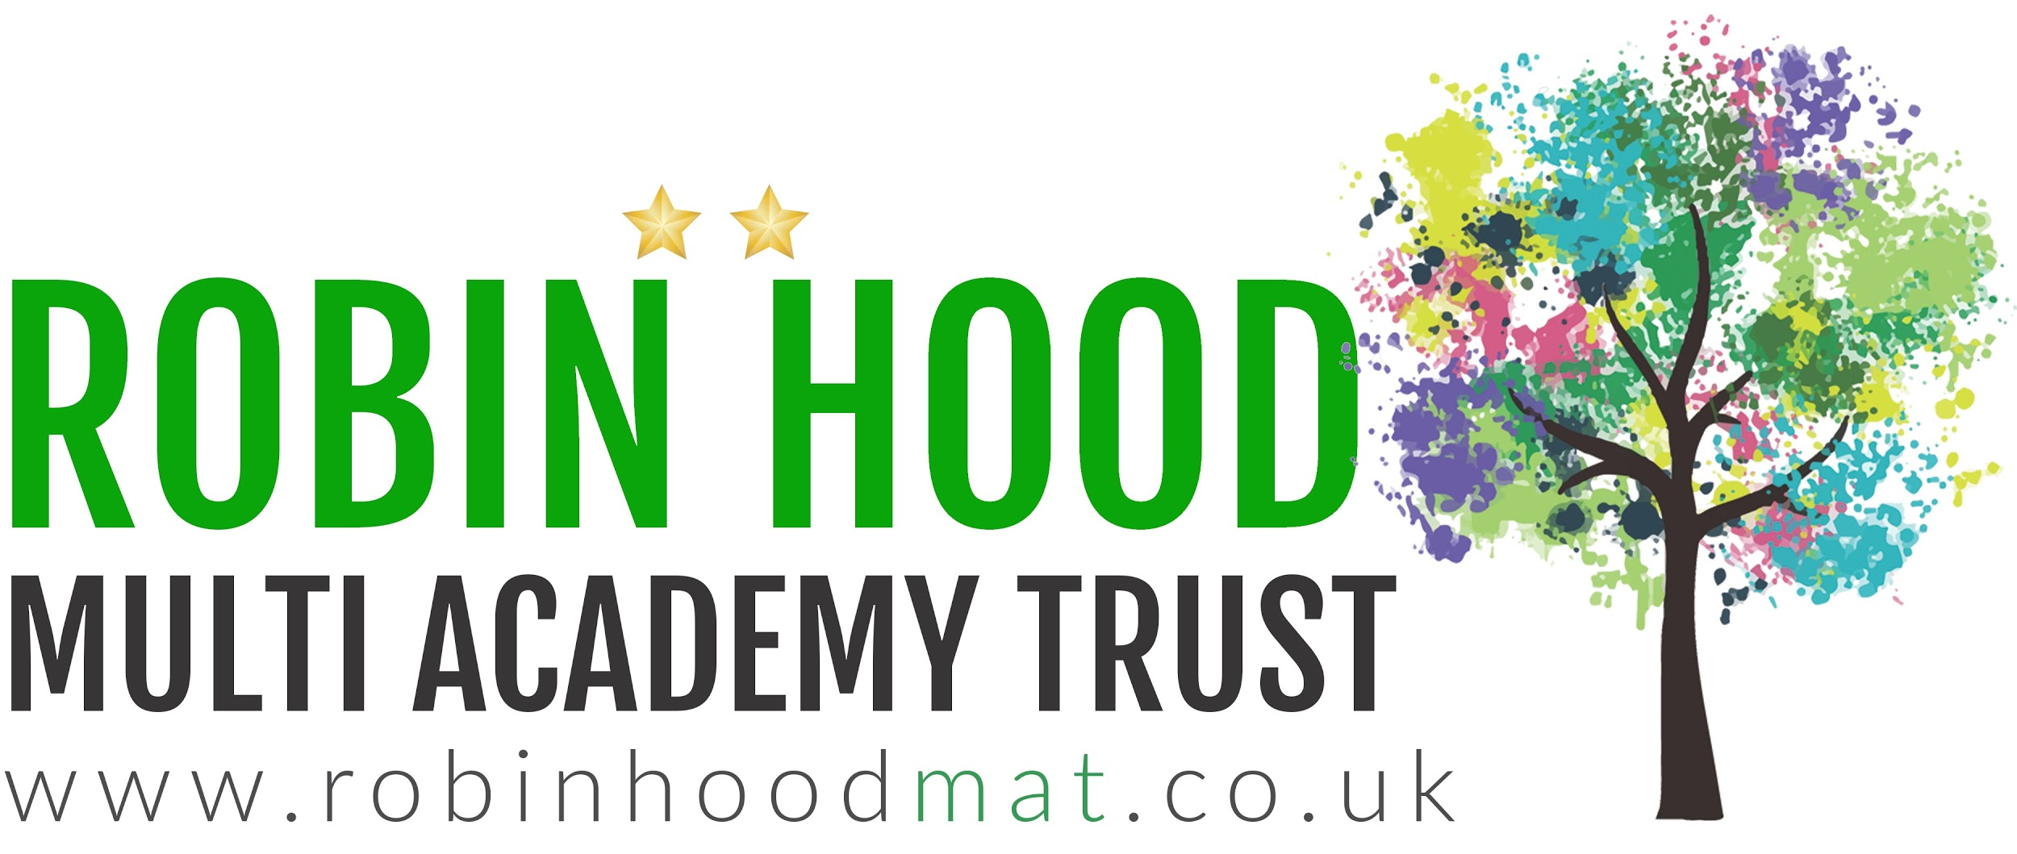
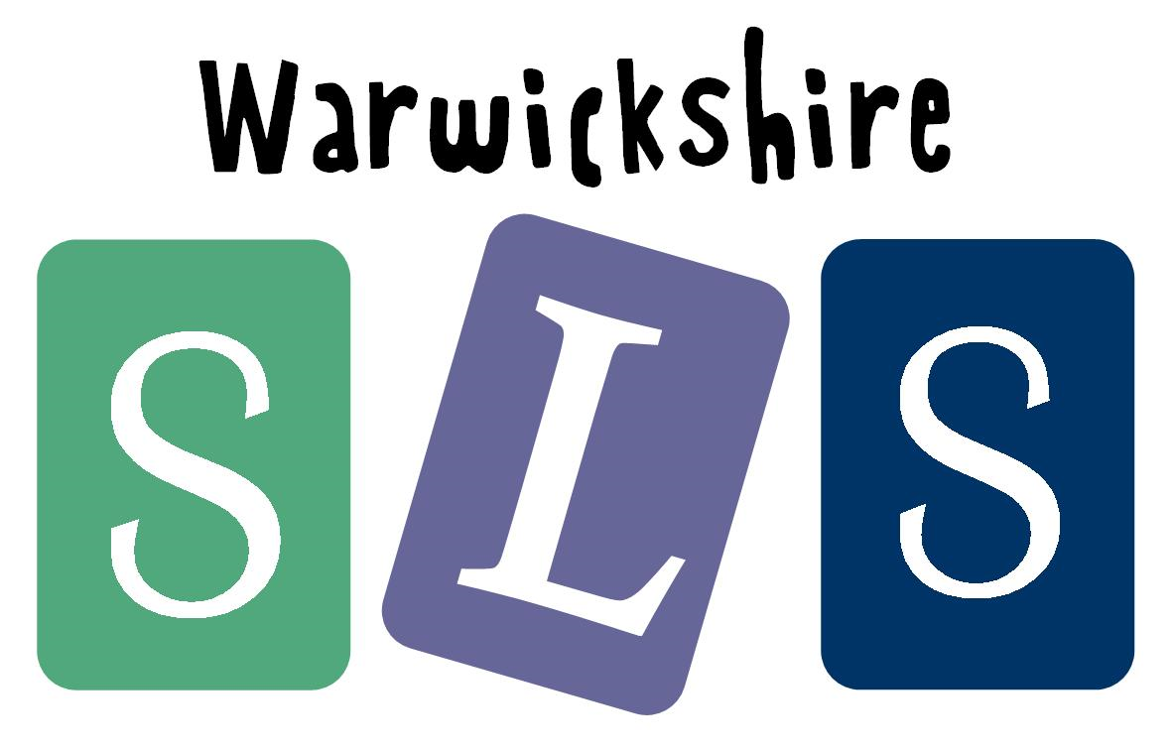
www.robinhoodMAT.co.uk

