Week 9 : Learning Project – Sport
Online
Age Range: Y3/4
Weekly Reading Tasks | Weekly Spelling Tasks
Monday- Encourage your child to read for enjoyment- perhaps in the garden for a change. Or complete some reading comprehension activities- here are some all about British female athletes. | Monday- Task your child with choosing 5 sporting activities that they’re unsure of how to spell and encourage them to learn to spell them. Can they apply these words into sentences?
Tuesday- Visit Worldbookonline eBooks using Username: wbsupport and Password: distancelearn. Search for the title Play Sports! and ask your child to read the eBook. Encourage them to complete the activities at the back of the book. | Tuesday- Practise spelling these words: myth, gym, Egypt, pyramid, mystery. Can your child identify the spelling rule? (The ‘ɪ’ sound spelt ‘y’ elsewhere than at the end of words).
Wednesday- Research and read online with your child about The Olympics. Which sport/s would they like to try? Why? Write 10 facts about The Olympics. | Wednesday- Alphabetical order: List each letter of the alphabet and ask your child to think of a sport related word that corresponds with each letter.
Thursday- Listen to these BBC children’s sport podcasts. Or your child can look through newspapers/ magazines and list all of the sporting vocabulary they find. | Thursday- Rainbow words. Choose 5 Common Exception words and choose different colours to write each letter and create rainbow words.
Friday- Ask your child to read this extract from Quiz Whiz Sport. Encourage them to answer the questions on each page and record these in full sentences. | Friday- Proofread writing tasks from this week. Your child can use a dictionary to check any spellings that they’re unsure of using the first2/3 letters of the word.
Weekly Writing Tasks | Weekly Maths Tasks- Position and Direction  Choose a task or tasks from each day. These are to be used flexibly
Monday- Visit the Literacy Shed for this wonderful resource on The Catch. Or, your child could write their very own celebration song. | Monday-  Y3 Play Simon says with an adult – focussing on the terms whole turn, half turn, quarter turn, three quarters turn.  As an extra challenge practise these terms by using toys instead of you. What do you notice about the direction which they are facing. Make the link that a quarter turn is a right angle – 90 degrees, half turn – 180 degrees three quarter turn - 270 degrees, full turn – 360 degrees.  Task Draw the starting position of an object. Predict and draw what you think it will look like having turned a quarter turn, half turn, three quarters turn.  Then check your pictures to see if you was correct.  Y4  Practise reading co-ordinates from the grid above or as an extra challenge why not create your own colour or number grid like this one.  You may also want to play this game to practise your co-ordinate skills.  White Rose Maths online daily maths lessons  Bitesize Maths online daily maths lessons  CODE Maths Hub Daily Fluency Activities - Day 1 Week 4
Tuesday- Ask your child to choose a sports person they admire. Get them to write a list of questions they would like to ask them. They could answer in role as their hero. Ensure your child uses a range of question words. | Tuesday-  Y3 Task  Create your own grid like the one below using drawings of sport related objects or even your key spelling words.  Get your child to describe the position of each object in relation to the other using positional words such as above below, beside, next to, to the left of, to the right of etc.  .  As an extra challenge choose a start and finish place and get your child to describe how they reach the finishing place.  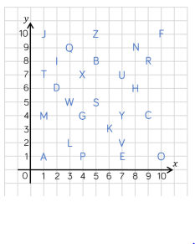  Y4 Ask your child to write out the co- ordinates which spell their name.  Task – Create your own co –ordinates grid like the one above.  Write down the co-ordinates of the names of people in your family. Can members of your family identify the names which you have made.  Your child may also any want to play Alien Attack using the first quadrant. Can your child describe the positions of the alien spaceships?  White Rose Maths online daily maths lessons  Bitesize Maths online daily maths lessons  CODE Maths Hub Daily Fluency Activities - Day 2 Week 4
Wednesday- Your child could devise their very own sport, including rules, equipment needed and a scoring system. Why not test the sport out? | Wednesday  Y3 Draw a picture of yourself. Sit back to back with an adult. Describe your picture using positional language. See if your partner can copy the picture exactly as you described it.  Y4 Create a picture by mapping out the co –ordinates or play ‘Hit the Coordinate’ to practise plotting coordinates on a grid.  White Rose Maths online daily maths lessons  Bitesize Maths online daily maths lessons  CODE Maths Hub Daily Fluency Activities - Day 3 Week 4
Thursday- Encourage your child to continue this story starter (right of site) and write their own Underwater Olympics story using this picture as a stimulus. | Thursday (theme)- Set up a Times Table relay race. Can your child run lengths of a space and count in their times tables forwards and backwards?  Year 3 tables focus 3x 4x 8x  Year 4 all tables upto – 12x 12.  White Rose Maths online daily maths lessons  Bitesize Maths online daily maths lessons  CODE Maths Hub Daily Fluency Activities - Day 4 Week 4
Friday- Ask your child to choose a sport, which is popular in another country, and write their own set of instructions for how to play that particular sport. | Friday (theme) – Look at the online medal table from 2012 from NRICH website.  Create an Olympic poster showing key information.  White Rose Maths online daily maths lessons  Bitesize Maths online daily maths lessons  CODE Maths Hub Daily Fluency Activities - Day 5 Week 4

Learning Project - to be done throughout the week
The project this week aims to provide opportunities for your child to learn more about sports and games. Learning may focus on the history of sport, sporting-heroes, physical challenges and performance.

- Our Sport Heroes- How many famous sports people can your child name? Ask them to choose a sports person and research online about them. Can they find out how and when they started their career, or any other interesting facts about them? Encourage your child to create a timeline that details all of the achievements of their sporting hero.

- Tissue Paper Sports Logo - Ask your child to use scrunched up tissue and paint to recreate the logo for their favourite sport team or design and create their own sport logo, perhaps for their school team. Your child could sketch this with pencils as an alternative.

- Super Movers! - Encourage your child to take part in this football themed Super Movers! There are two levels - Super Movers are a great way to keep active and have fun! Try Go Noodle and dance along to one of their routines - there’s plenty to choose from and the whole family can join in! Remember to tweet a video of their workout #TheLearningProjects. Your child could design a poster encouraging others to take part in sporting activities. Ask them how they would persuade others to join in. What type of words could they use? Recommendation at least 2 hours of exercise a week.

- Sharing Sport Interests - Encourage your child to ask different family members about their favourite sports and any sports they took part in growing up - were they a part of any clubs? Did they take part in any competitions? Did they win any trophies? They might find out something new about their family members! Following this, can your child use the information to write a newspaper report recounting one the memorable events? They could include quotes from the interview.

- Powerful Paralympians - You could explore diversity in sport with your child. Ask your child to find out about the Paralympic games and famous paralympians such as Ellie Simmonds. How have these people overcome challenges to represent their country in their chosen sport? They could write a letter/email to a chosen athlete and ask them questions about their sporting journey. Or they could draw a detailed sketch of the athlete during a winning moment.
Mindfulness
Encouraging your child to have some focused mindfulness time is a great way to help them cope with any difficult feelings or emotions that they might be experiencing at the moment. Mindfulness activities also contribute to brain health and general wellbeing.
Your child can start with short amounts of time and build up as they develop the ability to be still, calm and quiet.
This week we will bring our attention to different parts of our body.
After your child has done something energetic, like dancing or kicking a ball around the garden, have them take time to lie down with their hands on their chest. Ask them to close their eyes and tune into the feeling of their heart pumping and their chest rising and falling with each breath. Now ask them to bring their attention to their toes, feeling into their little toes and across to their big toes. Keep the focus here for a few slow breaths. Now ask them to bring their attention up to their ankles, then their calves, shins, knees, etc. Keep guiding them to gradually bring their attention in an upwards direction, stopping to take slow deep breaths at each body part. When they get back to their chest, ask them to again tune into the beating of their heart and the feeling of their breath. Have them remain here, just breathing and staying still, for about 5 minutes.
STEM Learning Opportunities #sciencefromhome
Body Facts or Body Fiction
- Have a look at the body facts or body fiction worksheet here.
- Use a ruler or tape measure to find out if your foot is as long as your forearm or your height is the same as your arm span. The complete resource can be downloaded here.
Additional learning resources parents may wish to engage with
- Maths
- Times Table Rockstars and Numbots. Your child can access both of these programmes with their school logins. On Times Table Rockstars, children should aim to play Soundcheck for 20 minutes daily.
- CODE Maths Hub Daily Fluency Activities - Week 4
- https://www.topmarks.co.uk/maths-games/daily10 - arithmetic challenges
- IXL online. Click here for Year 3 or here for Year 4. There are interactive games to play and guides for parents.
- BBC Bitesize - Lots of videos and learning opportunities for all subjects.

- Classroom Secrets Learning Packs - Reading, writing and maths activities for different ages.
- Twinkl - Click on the link and sign up using your email address and creating a password. Use the offer code UKTWINKLHELPS.
.
- Y3 Talk for Writing Home-school Booklets and Y4 are an excellent resource to support your child’s speaking and listening, reading and writing skills.
#TheLearningProjects
in collaboration with
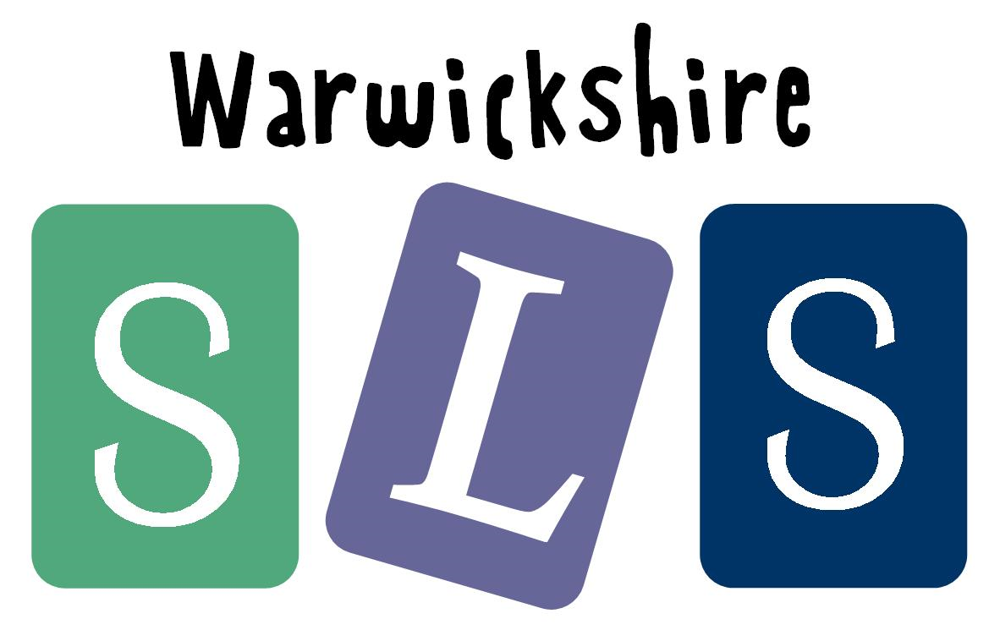
www.robinhoodMAT.co.uk

