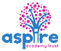
Learning Project - Around the World
Age Range: KS1
Weekly Reading Tasks | Weekly Phonics Tasks
Monday- Explore different countries around the world using the BBC Bitesize website. Can they write a postcard imagining they have visited that country and describing what it is like? | Monday- The word ‘around’ contains the sound ‘ou’. Ask your child to list as many words as they can containing the ‘ou’ sound. Your child might identify words that contain an alternative spelling for ‘ou’ such as ow.
Tuesday- Follow the story Here We Are with your child. What makes our world so special? Using the story, your child can make a list or draw illustrations. | Tuesday- Practise spelling days of the week using different materials in the house. Can you write the words in string? Can you build the words out of cardboard boxes? Could you write the words in cooked spaghetti?
Wednesday- Help your child to look through cookery books or leaflets from supermarkets for a recipe originating from another country. Ask them to use decoding skills to read some of the ingredients. Why not make it if you have the ingredients! | Wednesday- ‘Where’, ‘would’, ‘people’, ‘clothes’ and ‘water’ are some of the words that children in KS1 need to be able to spell. Can your child use these to write sentences about a contrasting country?
Thursday- Use an atlas, map or Google Earth and locate countries that make up the UK. Your child can then locate a contrasting country such as Brazil, Kenya or Australia. What is different? What is the same? | Thursday- Can your child list places from around the world using the alphabet? Can they add an adjective before each place that starts with the same letter?  Practise your weekly spellings:  Here, there, where, one, once, love, ask, friend, school, put
Friday- Follow the story When I Coloured in the World. What would your child change about the world? Task them with drawing a picture of their ideal world. | Friday- Recognise vowel and consonant digraphs and blending by playing this game or add suffixes playing this game.
Weekly Writing Tasks | Weekly Maths Tasks- Subtraction  Choose a task or tasks from each day.
Monday- Ask your child to create a leaflet about a place in the world they would like to visit or have visited. Include the weather, landmarks and cuisine. What towns and cities could they visit? What natural and man-made sights might they see? | Monday-  Y1/2 Create your own fact families poster for 10  See how many different ways you can represent each fact.  Below are some ideas from the NCETM to help you.  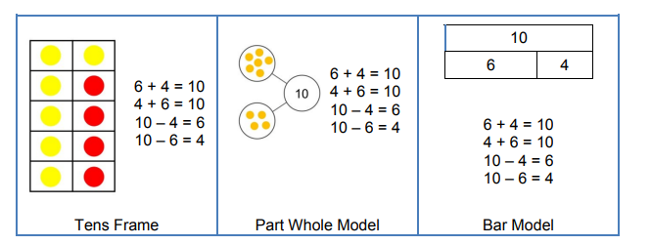  Y2 As an extra challenge you may want to include your fact families from 100  Practise your mental maths skills for both addition and subtraction by playing this game.  White Rose Maths online daily maths lessons  Bitesize Maths online daily maths lessons  CODE Maths Hub Daily Fluency Activities - Day 1 Week 7
Tuesday- Follow the story Here We Are with your child. Can they write a description of something from earth they think is special? Or write a description of what makes the whole earth special? Could they choose an animal or person to describe? | Tuesday-  Play Strike It Out game by NRICH to practise your addition and subtraction facts to 20.  Number lines to 20 are available on the NRICH page or you may want to draw your own.  Alternatively, create your own addition and subtraction facts to 20 board game  For this you may want to write both addition and subtraction calculations and base it on a county to link with the ‘Around the World’ theme.  Here is an online game to practise subtraction facts up to 20.  White Rose Maths online daily maths lessons  Bitesize Maths online daily maths lessons  CODE Maths Hub Daily Fluency Activities - Day 2 Week 7
Wednesday- Your child could write a set of instructions for a meal they would love to share with family and friends. They can use illustrations too. Don’t forget to use time conjunctions – first, next, then, after that. As well as imperative verbs – cut chop, mix, stir. | Wednesday-  Practise your subtraction skills by creating their own part part whole models.  like the ones below  Y1 Y2  68  199  177  8  Y1 Create using your own number cards to 20.  Select a 2 digit number and draw on the part part whole model ( in the whole circle)  Then pick up a single digit and place in one of the part circles  Then subtract the part from the whole i.e. 19 – 8 =  Y2 Do the same activity but create your own digit cards to create your own pairs of 2 digit numbers.  Remember the largest amount must be at the top in the whole circle.  Y1/2 Encourage your child to practise different ways to subtract by playing these different activities.  White Rose Maths online daily maths lessons  Bitesize Maths online daily maths lessons  CODE Maths Hub Daily Fluency Activities - Day 3 Week 7
Thursday- Your child could write a letter to a friend or a family member who lives in a different part of the world - describe where you live and describe what your school is like. Think of questions to ask about where they live and about their school. | Thursday (theme)- Look at flags from around the world either in books or on the internet. Ask your child to list any shapes they see and name the properties of the shapes they find. Ask your child how many lines of symmetry the flag has.  White Rose Maths online daily maths lesson  Bitesize Maths online daily maths lesson  CODE Maths Hub Daily Fluency Activities - Day 4 Week 7
Friday- Visit the Literacy Shed for this wonderful video The Black Hat and try some of the Resources.  Or your child could write their own version of When I Coloured in the World. | Friday-  Complete the Maths Challenges based on Around the World in 80 days by the cyclist Mark Beaumont. These can be found on Twinkl website.  Encourage your child to practise different ways to subtract by playing these different activities.  White Rose Maths online daily maths lesson  Bitesize Maths online daily maths lesson  CODE Maths Hub Daily Fluency Activities - Day 5 Week 7

Learning Project - to be done throughout the week
The project this week aims to provide opportunities for your child to learn more about countries and cities around the world. Learning may focus on different cultures and traditions, famous landmarks, food and clothing.

- Flags- Look at flags from around the world with your child. Discuss which are your child’s favourites and why? Ask your child to recreate their favourite; this could be through drawing, collaging etc. Can they place the flag on a map? There are some quizzes that your child can have a go at here. Can they create their own quiz about the UK?

- Dance Around the World- Watch the following dances: Diwali Stick Dance, Maypole Dancing and Spanish Flamenco Dancing. Encourage your child to have a go at some of the moves used in these videos. Record the dances and ask your child to evaluate what they did well and what they could do even better when watching them back. Can your child recreate one of the costumes using items from their wardrobe? Perform the dance to a family member. Perhaps you could upload onto Google Classroom for your teachers to see.

- Food Tasting Fun- Find some different fruits from around the world. This could include: mangos, kiwis, pineapples, bananas. Encourage your child to try them and have a discussion about which ones they liked and which ones they did not like. Cut the fruits open and task your child with sketching the inside of each fruit. Remind them to look closely at the patterns and shapes.

- Where in the World? - Have a discussion with your child about your own family heritage. Discuss with them your traditions and where your family originates from. This may be where you live now or it could be somewhere completely different. Ask your child to create a poster or PowerPoint all about their own family. Can they include a map identifying the country they’re from? Share these on Twitter at #TheLearningProjects, so children can compare families.

- Speak the Language- There are lots of different ways to say hello around the world. Learn how to say hello in Spanish, French, Mandarin, German, Arabic and Italian with your child using Google Translate. Practise writing hello using the colours of the flag for each country.
Mindfulness
Help your child find a safe space where they can lie down quietly with their eyes closed for a few minutes (this is a lovely activity to do outside if the weather is good).
Ask them to take a few deep breaths to relax their body. Tell them to imagine they are on a magic carpet that can fly anywhere in the world. Where would they like to go? Will it be somewhere warm, or somewhere cold, or maybe they would like to travel into space. Encourage your child to imagine how it feels as the magic carpet lifts them off the ground and up into the sky. Can they feel the wind on their skin, hear the birds flying past or sense damp clouds moving close by? Tell them the magic carpet is now flying closer to the ground near their chosen destination. Ask them to imagine looking down over the edge of the carpet. What can they see? What can they hear? How does it make them feel?
Encourage your child to take slow, deep breaths as they carry on their magical journey for as long as they like.
If your child finds it difficult to close their eyes and imagine somewhere else in the world, you could show them some photographs, or pictures in a book, and then try the activity again.
STEM Learning Opportunities #sciencefromhome
Engineering Around the World - World’s Largest Steel Structure
- The Bird’s Nest is the world’s largest steel structure and was built in China for the 2008 Olympic Games. It is made out of 26 miles of steel.
- Use strips of paper, card or wool to create your own bird nest style building. You might like to search for photos of the ‘Birds nest’ to help you with your design.
Additional learning resources parents may wish to engage with
- White Rose Maths online maths lessons.
- Bitesize Maths online maths lessons
- Numbots. Your child can access this programme with their school login.
- IXL- Click here for Year 1 or here for Year 2 . There are interactive games to play and guides for parents.
- Y1 Talk for Writing Home-school Booklets and Y2 are an excellent resource to support your child’s speaking and listening, reading and writing skills.
#TheLearningProjects
in collaboration with
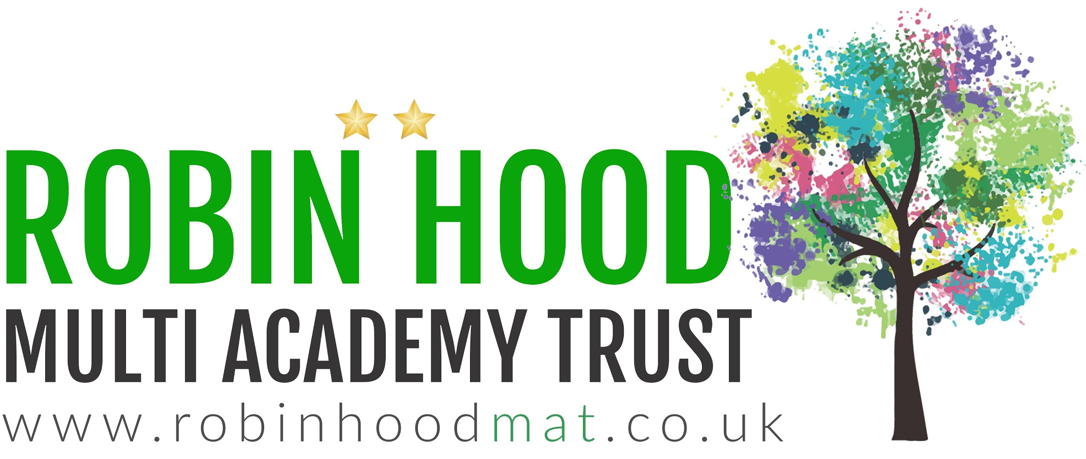
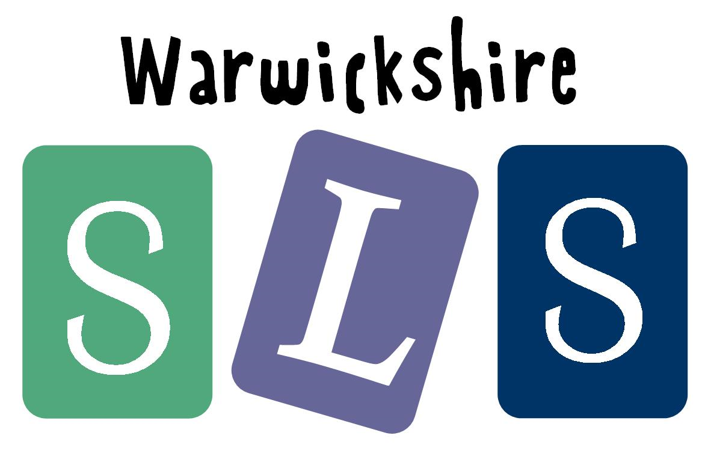
www.robinhoodMAT.co.uk

