Week 10: Learning Project - The Rainforest- Online
Age Range: KS1
Weekly Reading Tasks | Weekly Phonics Tasks
Monday- Create a sock puppet based on a favourite story character. Show your child how to use the puppet to retell the story the character appears in. | Monday- Can your child think of an animal or plant that begins with each letter of the alphabet. How many of these can be found in a rainforest?  Daily Phonics- Practice the sounds your child is working on and blend words. This can be oral blending (Fred Talk) or written if appropriate.
Tuesday- Watch Eric Carle’s Slowly, slowly, slowly, said the Sloth or Rumble in the Jungle. Once your child is familiar with the story, they can read along or join in with familiar sentences. | Tuesday- The tree frog, spider monkey and boa constrictor are just some of the animals that can be found living in a rainforest. Ask your child to list verbs (action/doing words) to describe how each animal moves. How many can they think of?
Wednesday- Ask your child to go and read in a sunny spot in the garden or by a sunny window. How did it make them feel reading outside? How did the sun feel on their skin? | Wednesday- Your child could visit this interactive game and play Forest Phonics.  Spellings:  Year 1- have, live, give  Year 2- hour, move, prove, improve, sure, sugar
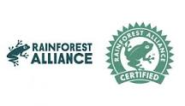  Thursday- Some of our everyday food comes from the rainforest. Your child can look in the kitchen cupboards and identify foods with the ‘Rainforest Alliance’ logo. | Thursday- This game helps your child to practise the ‘tricky’ words for their year group in a fun, interactive way.
Friday- Help your child to look through cookery books for a recipe involving chocolate. Ask them to use decoding skills to read some of the ingredients. They can learn about where chocolate derives here. | Friday- The word ‘rain’ contains the sound ‘ai’. Ask your child to list as many words as they can containing the ‘ai’ sound. Your child might identify words that contain an alternative spelling for ‘ai’ such as ay/a-e.
Weekly Writing Tasks | Weekly Maths Tasks- Fractions  Choose a task or tasks from each day.
Monday- Your child could start a nature diary. At the same time each day, they could record the animals that they can see in the garden or from their window and describe the weather and plants. What differences do they notice over the week? Or a month? | Monday- Cut pieces of paper into different shapes or food that can be sliced, then work with your child to find half by cutting or drawing on the shapes or by slicing the food. Make sure both sides are equal and if they aren't, talk about why it is not half. Repeat for finding a quarter.  Bitesize Maths online daily maths lessons with worksheets  White Rose Maths online daily maths lessons use the bitesize link for worksheets  CODE Maths Hub Daily Fluency Activities - Day 1 Week 5
Tuesday- Can your child create a fact file about a spider monkey or a tree frog? Describe the animal’s appearance, habitat, diet and any other facts. | Tuesday- Select an even number of some of your children’s toys (e.g. toy cars, marbles). Work with your child on splitting the total amount in half by sharing out into 2 piles. Repeat this to find a quarter but share the amount into four piles.  Y2 progress to finding ¾ of an amount and a 1/3 of an amount.  White Rose Maths online daily maths lessons  Bitesize Maths online daily maths lessons with worksheets  CODE Maths Hub Daily Fluency Activities - Day 2 Week 5
Wednesday- Your child could write a short description of the rainforest. Ask them to think about what they can see, hear, feel and smell. This live stream may help. | Wednesday- Get a chocolate bar and work with your child on how it could be split into half, quarters and thirds. You could investigate whether the size of the chocolate bar affects how much they get. Does ½ always look the same?  White Rose Maths online daily maths lessons  Bitesize Maths online daily maths lessons with worksheets  CODE Maths Hub Daily Fluency Activities - Day 3 Week 5
Thursday- Many trees in the rainforest are chopped down to use for paper. Ask your child to create a poster about saving and reusing paper at home. | Thursday – Choose a target fraction which you have been focussing on this week. Create a poster like the one below showing the different ways in which it can be represented but leaving out the decimals and percentages parts.  Y1 ½ or ¼  Y2 1/2 , I/4, ¾ or 1/3  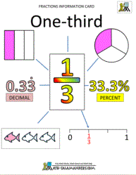  White Rose Maths online daily maths lessons  Bitesize Maths online daily maths lessons with worksheets  CODE Maths Hub Daily Fluency Activities - Day 4 Week 5
Friday- Visit the Literacy Shed for this wonderful resource on Caterpillar Shoes. Or, write an acrostic poem about a rainforest creature. | Friday- (theme)- With your child estimate and count the number of different plant types or insects that they can see/find in the garden. Record in a table or as a block graph ( like the example below)  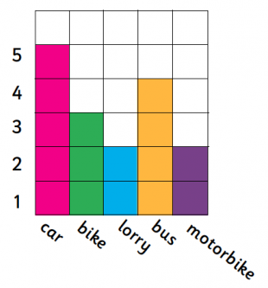  White Rose Maths online daily maths lessons  Bitesize Maths online daily maths lessons with worksheets  CODE Maths Hub Daily Fluency Activities - Day 5 Week 5

Learning Project - to be done throughout the week
The project this week aims to provide opportunities for your child to learn more about the world’s rainforests. Learning may focus on the plants, animals and insects that inhabit the rainforest, food that originates there and weather patterns. It could look at plants and animals that can be found in the garden too.

- Fascinating Forest Floor- Can your child create their own replica forest floor? Task them with collecting materials from the garden, during your daily exercise or with paper.

- The Sounds of the Rainforests- There are many wonderful and intriguing sounds that can be heard in the rainforest. You can listen and watch real footage from a rainforest here or watch this BBC Our Planet clip. Which animal makes the most noise in the rainforest? Ask your child to record what sounds they can hear and to predict what animals the sounds have come from. Can your child replicate these sounds using objects from around the home?

- Where in the World are the Rainforests?- Using an atlas or online map, can your child locate the continents (Africa, Asia, Australia, Central America and South America) where rainforests can be found? If this is too challenging, can your child locate one country with a rainforest, and then locate the UK. Ask them to describe the similarities and differences between the UK and the country they have located.

- The Big Garden Tidy Up- Why not work together as a family and have a Big Garden Tidy Up? Task your child with pulling out weeds, raking up the leaves or just having a general tidy. Take before and after photographs.

- Sketch a Spider Monkey or a Tree Frog- Can your child create a detailed sketch of an animal that inhabits the rainforest? Using pencils, crayons or whatever else you have, ask your child to copy an image of a rainforest animal, thinking carefully about the patterns and tones.

- Mindfulness - This week we will use sound to help us relax.
You can use this rainforest music or sit outside in the garden with the sound of nature around you as your focus.
Have your child sit or lie down in a comfortable position with their eyes closed. They might like to use a snuggly blanket, a cuddly toy or a cushion so that they feel cozy, safe and relaxed.
Ask them to close their eyes and stay still. All they need to do is listen to the music / sounds of nature. If any thoughts pop into their head, you can tell them that the thoughts are just like clouds and float away. Every time a thought comes along, just let it float away like a cloud and continue listening to the sounds.
You can do this for 3 – 5 minutes every day, or for as long as your child feels able to focus.
STEM Learning Opportunities #sciencefromhome
Rainforest Insects
- Watch this video.
- There are lots of insects/mini-beasts in the rain forest. You can see some pictures of them here.
- Look for mini-beasts living in the garden or on a walk. What are these mini beasts called? Which one do you like the best and why?
- Try drawing pictures of the mini-beasts you find.
Additional learning resources parents may wish to engage with
- The Rainforest Alliance website is packed full of information, resources and games which may support some of the above activities.
- Maths
- White Rose Maths online maths lessons.
- Numbots. Your child can access this programme with their school login.
- IXL- Click here for Year 1 or here for Year 2 . There are interactive games to play and guides for parents.
- Mastery Mathematics Learning Packs Learning packs with different activities and lessons. Includes notes on how to do these activities with your children.
- Y1 Talk for Writing Home-school Booklets and Y2 are an excellent resource to support your child’s speaking and listening, reading and writing skills.
#TheLearningProjects
in collaboration with
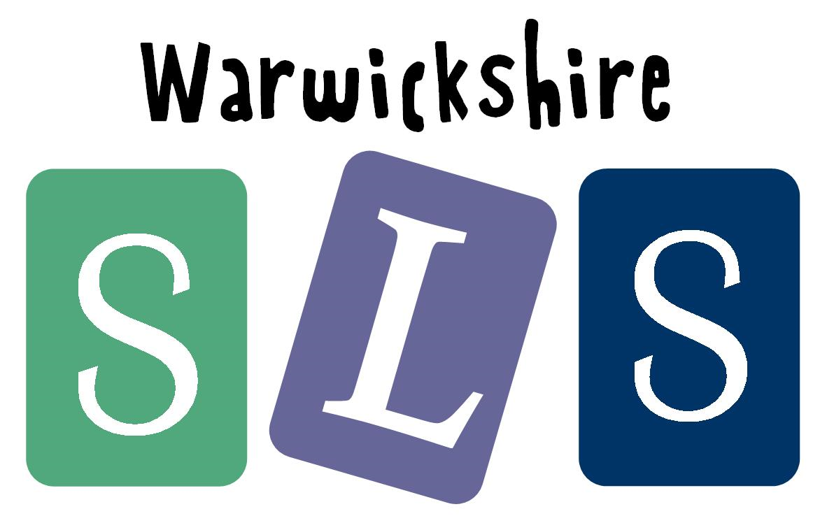
www.robinhoodMAT.co.uk

