Learning Project - Music
Age Range: Y3/4
Weekly Reading Tasks | Weekly Spelling Tasks
Monday- Look with your child at this poster pack of musical styles. Read through the information for each musical style and find a song to listen to. Ask your child to identify their favourite music styles giving reasons for their choice. | Monday- Ask your child to learn to spell the names of an instrument from each of the instrument families (strings, woodwind, brass, keyboards, and percussion).
Tuesday- Ask your child to find the lyrics to their favourite song and highlight some creative words used, finding out the meaning of new words. | Tuesday- Practise spelling these words: measure, treasure, pleasure, enclosure. Can your child write a definition for each of these words?
Wednesday- Do you have any CDs or records in the house? If so, ask your child to organise them in alphabetical order or by genre. If not, provide them with a list of musicians where they can do the same thing. | Wednesday- Ask your child to unscramble these musical words: empot, demloy, epslu, narhmoy & rrecsttuu.
Thursday- Visit Audible and let your child choose a book to listen to. Ask them to write a review when they have finished (free audio books available). | Thursday- Memory. Write as many of this week’s spellings down from memory as you can. How many did you recall? Practise any you have missed.
Friday- Your child can listen to BBC School Radio music episodes here. These episodes are based on Treasure Island and your child will learn new songs. | Friday- Practise the Y3/4 spellings in this fun, interactive way. Encourage your child to note down any words they are unfamiliar with and clarify them.
Weekly Writing Tasks | Weekly Maths Tasks- Angles and Shape  Choose a task or tasks from each day. These are to be used flexibly
Monday- Visit the Literacy Shed for this wonderful resource on Once in a Lifetime or take part in a writing masterclass. | Monday-  Practise your understanding of parallel and perpendicular lines by playing this game.  Look at this picture on the Internet – see how many right angles in the environment you can find  White Rose Maths online daily maths lesson  Bitesize Maths online daily maths lesson  CODE Maths Hub Daily Fluency Activities - Day 1 Week 8
Tuesday- Listen to the piece of music called Peter and the Wolf, written by Prokofiev. Whilst listening, encourage your child to list any words that come to mind e.g. elation, cheerfulness. They could also draw a picture of what they think the song represents. | Tuesday- Ask your child to become a shape scavenger! How many examples of different 2D and 3D shapes can they find around the home/garden?  Practise sorting the 2d shapes by the number of sides and vertices ( corners) and the 3d shapes by their edges, vertices and faces extending to parallel lines and perpendicular lines.  As an extra challenge, why not play I am thinking of a shape where one person describes the shape and their partner has to guess which shape it is.  White Rose Maths online daily maths lesson  Bitesize Maths online daily maths lesson  CODE Maths Hub Daily Fluency Activities - Day 2 Week 8
Wednesday- Now listen to the story. Ask your child to write their own story that would be great told through music or draw a story map to represent this tale. Can they include speech too? | Wednesday- Ask your child to write their name in capital letters and see how many angles they can see in each letter or to look at flags from around the world using this website / activity  Y3 How many right angles can you find?  Y4 How many right angles, acute and obtuse angles can you find.  Repeat for other family names. You may want to use your angle information sheet from Monday to help you with this.  As an extra challenge you may want to create your own flags showing your understanding of angles.  White Rose Maths online daily maths lesson  Bitesize Maths online daily maths lesson  CODE Maths Hub Daily Fluency Activities - Day 3 Week 8
Thursday- Your child can make a mini-book about the instrument families. Include: names of instruments within that family, famous musicians who use them, country of origin and labelled illustrations. | Thursday- Explore the use of parallel lines, perpendicular lines and shapes in art by looking at this website. It will give you a good starting point and some ideas which you may want to use in your work.  As an extra challenge, create your own picture using shapes, parallel lines and perpendicular lines and discuss these features with an adult.  White Rose Maths online daily maths lesson  Bitesize Maths online daily maths lesson  CODE Maths Hub Daily Fluency Activities - Day 4 Week 8
Friday- Invent a new instrument. Ask your child to write a fact file about their instrument or design an advert for when the instrument goes on sale. | Friday- Create your own Musical Shape Pattern like the one below where each shape indicates how many times the rhythm has to be played as seen below.  You could also include a hexagon – 6 sides and an octagon 8 sides too.  = 4 times as it has 4 sides  = 3 times  = once  = 5 times  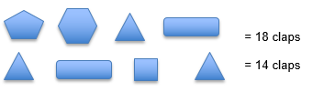  As an extra challenge you may want to use 3D shapes such as cubes, cuboids, pyramids, cones, cylinders and create your own pattern based on the number of faces, vertices or edges each one has.  White Rose Maths online daily maths lesson  Bitesize Maths online daily maths lesson  CODE Maths Hub Daily Fluency Activities - Day 5 Week 8

Learning Project - to be done throughout the week
The project this week aims to provide opportunities for your child to learn more about music. Learning may focus on famous musicians, listening to and performing music and exploring a range of music genres and instruments.

- Lean On Me - Encourage your child to listen to Lean On Me, a Soul/Gospel song by Bill Withers. Do they like it? What instruments can they hear? Can they clap a rhythm? Learn to sing the lyrics and have a go at performing the song. Perhaps your child would like to research this famous artist in more detail and listen to more of his songs, creating an artist profile complete with portrait sketch. Perhaps they could perform the song to a family member via Facetime (with adult supervision)? Share your performance at #TheLearningProject.

- Musical Makes - Ask your child to try creating their own music instrument. They could make their own pan flute using straws, a cereal box guitar, or some tin can drums. Encourage them to plan their design first, source materials from around the house, write the steps to make the product and then evaluate it afterwards. Or they could research Kandinsky and create their own instrument art inspired by his work whilst listening to different genres of music.

- Feel the Beat - Why not ask your child to have a go at moving their body to different genres of music. As you change between Rock, Jazz, Hip Hop, Heavy Metal and Classical music, how does the way they move their body change? Have a dance together to the beat of the music! Recommendation at least 2 hours of exercise a week.

- Listen Together - Encourage your child to ask each family member what their favourite song is. Play the song aloud and listen together. Spend some time as a family discussing what genre of music the songs belong to and how each piece of music makes you feel. Which genres of music were the most popular? Can your child represent their results in a bar chart? They could ask family members to rank their favourite genres of music first.

- Musical Movie Time - Allow your child to choose an age-appropriate musical to watch. Andrew Lloyd Webber is now posting filmed versions of his shows on his YouTube channel The Shows Must Go On! each week! Discuss the story behind the musical and ask your child to step into the shoes of different characters and imagine how they are feeling. Which is your child’s favourite song from the film/show and why? Can they create a billboard poster advertising the show? Or perhaps design a ticket?
STEM Learning Opportunities #sciencefromhome
Making Instruments
- You will need a jar/bottle, some water and a pencil. Try tapping the side of an empty container with a pencil. What type of sound does it make? Partially fill the container with water, tap the container again. Has the sound changed? Try filling the container with different amounts of water. Can you play a tune? Look here.
- Now try making a straw oboe. All you need is a drinking straw and some scissors. Cut the end of the straw into an arrow shape and blow gently. Once you get a duck type sound try altering the length of the straw. What do you notice?
- For more ideas take a look at the full resources here.
Mindfulness
Find a quiet space where you can sit or lay down comfortably without interruptions. This is your special mindfulness time which helps to keep your brain and body healthy. You are safe to close your eyes and relax.
Focus on relaxing your body as you listen to the music. Start by relaxing your toes, then your legs, next your stomach and chest, followed by your arms and hands. Finish by making sure your face is completely relaxed.
Now just focus on feeling your breath enter and leave your body as you listen to the music.

Stay here, just listening and relaxing for as long as you like.

Click this link for a music suggestion.

Additional learning resources parents may wish to engage with
- BBC Bitesize - Lots of videos and learning opportunities for all subjects.
- Classroom Secrets Learning Packs - Reading, writing and maths activities for different ages.
- Twinkl
- White Rose Maths online maths lessons.
- Times Table Rockstars. Your child can access this programme with their school login. On Times Table Rockstars, children should aim to play Soundcheck for 20 minutes daily.
- IXL online. Click here for Year 3 or here for Year 4. There are interactive games to play and guides for parents.
- Y3 Talk for Writing Home-school Booklets and Y4 are an excellent resource to support your child’s speaking and listening, reading and writing skills.
The Learning Projects are based on the National Curriculum expectations for the key stage which your child is in. It may be that your child finds the tasks set within the Learning Project for their year group too simple. If this is the case, then we suggest that your child accesses the Learning Projects which are set for the key stage above. Equally, if the projects are too challenging, then we advise that your child accesses the projects for the key stage below.
If your child requires more of a challenge, or you believe that there are some gaps in their learning then Century Tech is a fantastic resource that is currently free for home learning. The app is designed to address gaps and misconceptions, provide challenge and enables children to retain new knowledge. It uses artificial intelligence to tailor the learning to your child’s needs. Sign up here.
#TheLearningProjects
in collaboration with
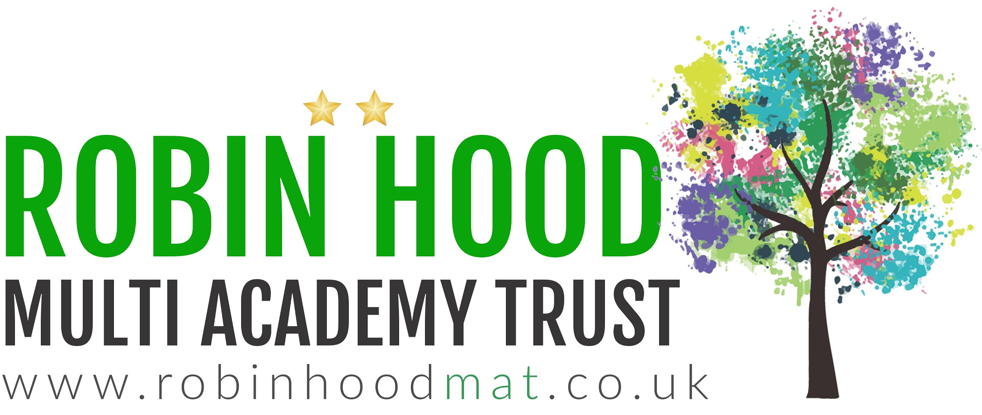
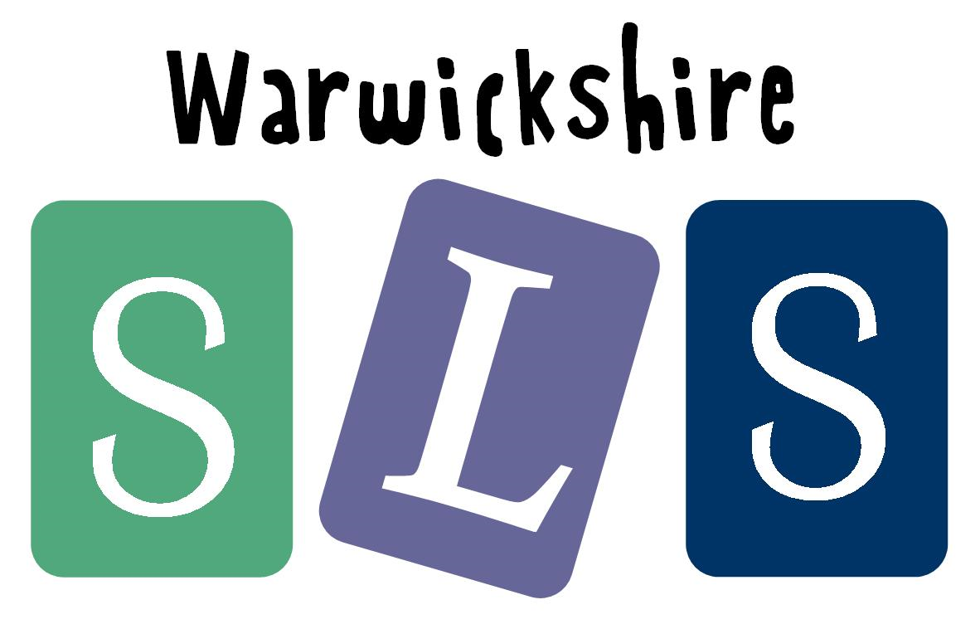
www.robinhoodMAT.co.uk

