List of Suggested Phonics Games and Activities

Hoop Game
Jump in phoneme (sound) hula-hoops with a sound represented in each one to make different words i.e. p-l-ay. If you do not have hula-hoops available, you could use different resources or chalk.

Sounds and Pictures Matching Game
Children match phoneme (sound) with the corresponding picture i.e. igh for high

Obb and Bob Game
Sort real and alien words by feeding the aliens on the PhonicsPlay website

Hangman
Chose a picture from a feely bag. Count how many phonemes (sounds) and draw the lines to represent them. Ensure longer lines represent digraphs (two letters one sound) and trigraphs. (3 letters one sound).

Musical Letters
Musical chairs style game. Pictures or words on chairs that the children sit on when the music stops, and they must shout out the phoneme (sound) or read the word.

Water Pistol Game
Children ‘shoot’ the phonemes (sounds) that are written either in chalk or on laminated cards. Adults to call out a sound and the children need to ‘shoot’ the sound as quickly as they can.

NSEW Game
Phonemes (sounds) are laid out like a compass (North, South, East and West) around an open space. Children run to sounds once called out.

Pairs
Phonemes are written on sticky notes, ensuring there are enough to make pairs. Children go around the room finding the different sounds. Once they have found two sticky notes with the SAME sound, they place them in a pair.

Clap the sounds
Clap out the sounds in words and attempt to write the word. How many sounds can you hear? Encourage children to use their Fred fingers to help them spell a word.

Jump to the Sounds
Show children a picture or word. Can the children jump as they sound out each letter? Can the children jump high to ‘drag’ out the sound if it is a digraph/trigraph?

Noughts and Crosses
Play phonics noughts and crosses. Draw out a grid and write a letter, digraph (sh, ng, nk, ay, ee), trigraph (igh, air) or tricky word in each part of the grid. Take it in turns to name what is written in the grid. If you say it correctly you can add your nought or cross in that square.
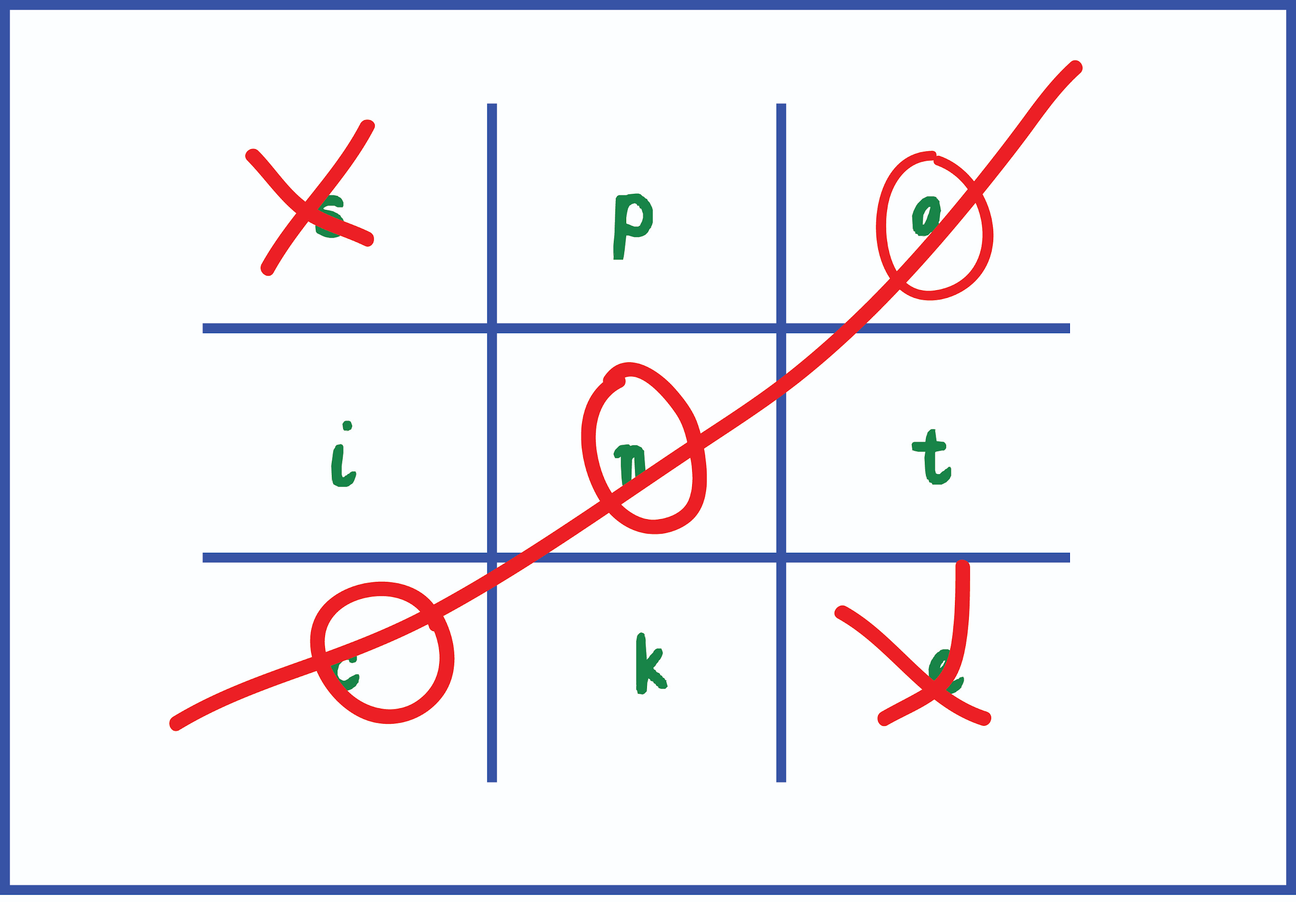

Beginning, Middle & End
Start by drawing a chart on a whiteboard or piece of paper which divides up into three sections for the beginning, middle and the end.
Start with one specific sound and read out phonetically plausible words which contain the sound. The children can then decide if the sound was found in the beginning, middle or at the end of that word i.e. z-i-p/w-i-g.

I Spy Game
The ‘I spy’ game has been around for a long time and is great for supporting children in recognising the sounds in words.
Instead of playing a truly challenging game of ‘I Spy’ where you can refer to anything within sight, try putting a collection of items in a box, this narrows down the amount of options available. Allow the children to take turns in selecting their own items in the box for challenging other children. This is great for group interaction, and everyone in the family will love playing it!

Sound Hopscotch
Using chalk, draw a standard hopscotch frame on the ground with some sounds in, rather than numbers. Children can throw a bean bag onto a specific sound, say it aloud and think of a word. They can then jump/hop etc. to the sound.

Missing Sounds
Draw or show a picture on a piece of paper. Next to it, write all but one of the sounds. For example, there is a picture of a dog on the board, you write ‘og’ beside it and the children have to provide you with the missing sound.
Who Can Cross the River?
Lay out 2 ropes or a large blue piece of material to represent river. Place 3 carpet squares as stepping stones across the river with 3 sound cards (one on each carpet square). The child sounds out the phonemes as she/he steps across the river, then blends the sounds together to hear the word.

Bingo
Sound or word bingo. Encourage children to write 6 sounds or words onto a grid. Then, call out a sound or word and encourage them to spot the word/sound and cross it off their grid. A great game for the whole family.

