Learning Project - Space
Age Range: KS1
Weekly Reading Tasks | Weekly Phonics Tasks
Monday- Ask your child to select a book and imagine they are reading it in space. Try reading it with a torch just before bedtime. Or upside down as if there is no gravity! | Monday- The word ‘space’ contains the sound ‘a-e’. Ask your child to list as many words as they can containing the ‘a-e’ sound. Your child might identify words that contain an alternative spelling for ‘a-e’ such as ai/ay/a.
Tuesday- Ask your child to listen to Look Up! read by the author and then take part in a drawing session with the book’s illustrator. | Tuesday- ‘there’, ‘move’, ‘climb’, ‘fast’ and ‘behind’ are some of the words that children in KS1 need to be able to spell. Can your child use these to write sentences about a rocket travelling into space?
Wednesday- Take a look at these videos that share facts about space and watch together. Planets on Oxford Owl has further facts. Does your child have any further questions about space that you could investigate? | Wednesday- Look at the words: want, wash, wasp, wand, swallow, squash, swap, squad, swamp, watch. Ask your children to sound talk the words and identify how the letter a should be pronounced in each of these words (/o/). Explain that when /w/ comes before vowels it can affect the pronunciation of the vowel.
Thursday- Ask your child to list any space related words from the books they have read or listened to this week. Can they write the meanings of each word? | Thursday- Write the names of the planets on separate pieces of paper and practise reading them. Can your child order them alphabetically?  Weekly Spellings: now, how, brown, down, town, own, blow, snow, grow, show
Friday- Listen to Beegu here. Can your child write a character description about Beegu? Encourage them to reference events from the story. | Friday- Play the online game ‘Yes/No Yeti’ or the ‘Suffix Factory’. Can your child list words that end in the suffixes: ing, en, ly?
Weekly Writing Tasks | Weight, Capacity and Temperature  Choose a task or tasks from each day. These are to be used flexibly
Monday- Ask your child to design their own rocket and create a bank of adjectives – shiny, tall, pointy, to describe it and verbs – zooming, whizzing, floating to describe how it moves.  Ask your child to find a book in your house. Can they find three items which are longer than the book and three items which are shorter? Order the items from longest to shortest. Measure the items to work out the difference in lengths. | Monday- Select containers, this could be different sized glasses, jugs, bowls etc. Ask your child to predict which will hold the most/least water. Pour cups of water to see which holds the most/least. For objects that are similar in size, predict how much water it will hold and then use a measuring jug to read the capacity.  White Rose Maths online daily maths lesson  Bitesize Maths online daily maths lesson  CODE Maths Hub Daily Fluency Activities - Day 1 Week 9
Tuesday- Now that they have designed their rocket, ask your child to create an advertisement of the rocket launch. How much will it cost? What time will it launch? Is there anything else on offer? | Tuesday- Ask your child to find a book (or any object which they choose) Can they find 5 items which are heavier than the book and items which are lighter than the book?  From this, sort the items into categories such as heavier than 100 grams or less than 100 grams.  As an extra challenge pick up 2 objects and compare their weight using the comparison signs.  i.e. 200 g > 100g ( is greater than)  400g < 300 g ( is less than)  White Rose Maths online daily maths lesson  Bitesize Maths online daily maths lesson  CODE Maths Hub Daily Fluency Activities - Day 2 Week 9
Wednesday- Ask your child to plan their own trip to space – what will they take and what will they do there? Record this in a timetable. | Wednesday- Select some containers/to practise your ordering of capacities or packets to practise your ordering of mass.  Draw and label the different containers in ml or l  Or packets in g and kg as appropriate.  Then put them in order smallest to largest or largest to smallest.  Practise your ordering skills of mass by playing this game.  White Rose Maths online daily maths lesson  Bitesize Maths online daily maths lesson  CODE Maths Hub Daily Fluency Activities - Day 3 Week 9
Thursday- Encourage your child to research facts about a planet of their choice and then create a fact file about their chosen planet. This could be Earth. | Thursday - Discuss with your child how different areas of our homes feel hotter / colder. Which room is the hottest/coldest? Discuss why this might be? Repeat the activity at a different times of the day, do we think the temperature changed? Why?  If you have a thermometer, work with your child to measure the temperature of each room in your home using a thermometer using the above questions.  Look at this website ( the three top line activities) about thermometers  Practise reading temperatures through playing this activity  Or look at this website to look at the different temperatures around the world..  White Rose Maths online daily maths lesson  Bitesize Maths online daily maths lesson  CODE Maths Hub Daily Fluency Activities - Day 4 Week 9
Friday- Watch the Disney short “La Luna” here. Ask your child to write a short diary entry in role as the little boy about his adventures. | Friday (theme)- Practise your addition and subtraction skills to 20 by completing these space activities.  White Rose Maths online daily maths lesson  Bitesize Maths online daily maths lesson  CODE Maths Hub Daily Fluency Activities - Day 5 Week 9

Learning Project - to be done throughout the week
The project this week aims to provide opportunities for your child to learn more about space. Learning may focus on our Solar System, the Sun and the Moon. It could look at life in outer space from the view of an astronaut and travelling through space.

- Our Solar System- Encourage your child to think about what they already know about space and create a mind map. Can they name the planets in our solar system? Use the Solar System Song to create a diagram showing the order of the planets. Or make real ones using balloons and Papier-mâché.

- Astronaut Aerobics- Astronauts have to be fit and agile for their missions into space – they work out 6 days a week for 2 hours a day when they’re in space. Ask your child to design a home workout and put your agility to the test! They could borrow some ideas from Joe Wicks. Then, your child can plan a day of healthy eating for the aspiring astronauts thinking carefully about each food group.

- What are Day and Night?- Share the video of day and night with your child. Watch the video and then create a poster about day and night explaining why we have day and night. Play the quiz and see how many answers you can get right!

- Rocket Creation- As part of their writing tasks, your child has designed a rocket. Ask your child to create their rocket using objects they can find in the home such as cardboard boxes, newspapers and tin foil. Can they write a set of instructions to share with a family member or friend? Share on Twitter at #TheLearningProjects. Or add to Google classroom for your teachers to see.

- Is There Anything out There?- Tim Peake is a famous British astronaut. Ask your child to record the questions they would ask him if they could interview him. Can they answer the questions in role as him? Why not task them with designing a new space suit for him? What would make a good space suit?
Mindfulness
To link to the space theme, how about helping your child make a space mobile to use as a relaxation tool. You could do this by cutting out some cardboard stars and dangling them from a coat hanger (feel free to be more creative!).
Find somewhere to hang the mobile so your child can lay down underneath and gaze up at the stars. It will work well outside with a gentle breeze to make the mobile move.
Encourage your child to keep their body and their mind still. Then focus on watching the stars move and the feeling of their breath entering and leaving their body.
Encourage your child to stay here for as long as they find comfortable.
STEM Learning Opportunities #sciencefromhome
Mission X – Astro Food
- Collect a variety of plant foods from home or download the cards from this resource.
- Group the food/cards e.g. fruits, seeds, vegetables. Which parts are edible?
- Sign up and access all of the Mission X resources here.
Additional learning resources parents may wish to engage with
- Further activities at Nasa for Kids.
- White Rose Maths online maths lessons. Watch a lesson video and complete the worksheet (can be downloaded and completed digitally).
- Numbots. Your child can access this programme with their school login.
- IXL- Click here for Year 1 or here for Year 2 . There are interactive games to play and guides for parents. .
- Y1 Talk for Writing Home-school Booklets and Y2 are an excellent resource to support your child’s speaking and listening, reading and writing skills.
#TheLearningProjects
in collaboration with
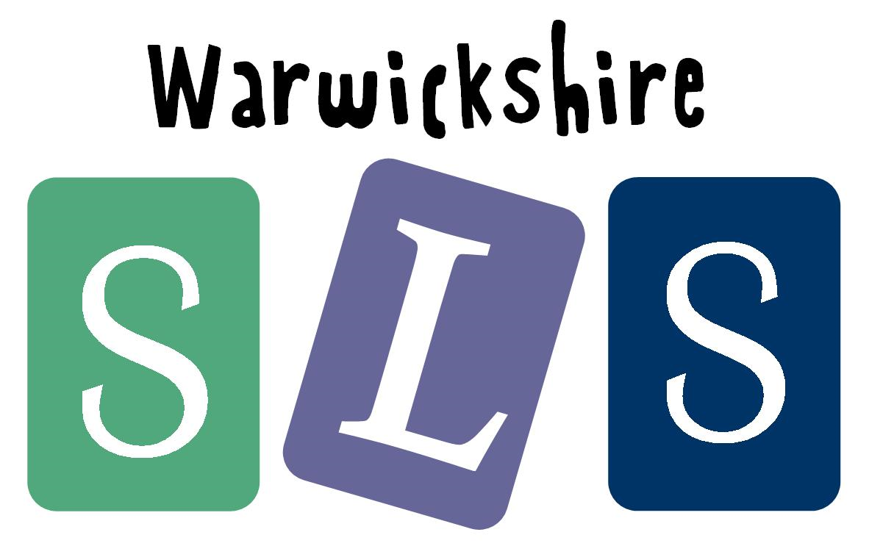
www.robinhoodMAT.co.uk

