Learning Project WEEK 6: Food -Online
Age Range: KS1
Weekly Maths Tasks (Aim to do 1 per day) | Weekly Reading Tasks (Aim to do 1 per day)
- Working on Numbots - your child will have an individual login to access this.  - Play on Hit the Button - number bonds, halves, doubles and times tables.  - Y1 Look in the cupboards and the fridge. Sort some of the foods you can find into different groups, they could be fruits and vegetables, things in tins or boxes, or whether they are a source of protein or carbohydrate. Which food group has the most or least number of items? Which item of food is the longest / shortest.?  Then play this game to practise your measuring skills  - Y2 Fractions  - Play this game to practise finding, ½ , ¼ and ¾ of shapes  - Data Handling  - Play the game Fruit Fall - answer the data questions based on how many pieces of fruit you catch.  - Shape  - Choose and draw a 2D shape of your choice. List how many sides, vertices and lines of symmetry it has.  Play shape match game here and talk about the different shapes and their properties with your child.  - All  - Design a poster showing what you learned in your daily Maths lesson you can be as creative as you want to be!  Daily Maths:  This site has daily Maths ideas which can be accessed online: http://www.codemathshub.org.uk/lockdown-resources/ (week 1) and this link for the daily maths lesson  https://whiterosemaths.com/homelearning/summer-term/ (takes you to bitesize)  Or the Bitesize link.  https://www.bbc.co.uk/bitesize/dailylessons  - These are available for Y1 and for Y2. | - Read out aloud the ingredients on the back of a tin or cereal box to an adult?  - Can you add the sound buttons onto three words that you found in the ingredients list?  - Find a recipe book in the house or online and read the ingredients needed to make something.  - Find a food leaflet in the house and read some of the items. Make a list of the food in alphabetical order and add on sound buttons to three of the items found.  - Read a variety of books and make a list of all the different types of food you find.  Free Ebooks that could be useful are:  Mix Mix Mix  The Big Carrott  Plants for Dinner  Leek Hotpot
Weekly Phonics/Spellings  Tasks (Aim to do 1 per day) | Weekly Writing Tasks (Aim to do 1 per day)
- Daily phonics – encourage your child to practice their sounds and blend words. Please visit: https://www.ruthmiskin.com/en/find-out-more/parents/ for more information and support.  - Interactive games found on link below.  - Phonics play  - Top Marks  - Spelling  - Spell the days of the week  - Spell common exception words  - Spelling City | Ask your child to:  - Create a shopping list for the week. Can your child group the items into food groups on their list e.g. fruit and vegetables, meat, dairy, fats and sugars.  - Write a recipe for a healthy meal of their choice. Use subheadings for the ingredients and instructions.  - Write a set of instructions for making toast. Can they use imperative verbs?  - Design a new label for a cereal box. What eye catching information will you add? Can you use an exclamation mark?  - Write a poem about your favourite food. Will it rhyme? Think about how you could present your poem – could you write it in the shape of your favourite food? Have a look at some examples here!  - Design a new milkshake. Which ingredients will you include? Can you write a list of all of the ingredients you used? Will you have a mascot that is linked to your new creation? See whether the other people in your house like the milkshake you have designed!
Learning Project - to be done throughout the week: Food
Food
The project this week aims to provide opportunities for your child to learn more food. Learning may focus on where different foods originate from, what makes a healthy meal, opportunities to cook etc .

There are lots of different activities and videos you could use from the Premier League Stars here

Balanced diet: Show your child this video about how to have a balanced diet.

Play these games about healthy eating.
What do we have today? Look in the kitchen to see if you can create an A-Z list of foods.

Fruit and vegetables - Draw pictures of fruit and vegetables in your house. Label the fruit and vegetables and place in alphabetical order.

Sorting activity: Collect food from the kitchen and sort into healthy and unhealthy foods – look at the traffic light labels on packets to help you!

Design a poster - Think about the foods you like to eat and food that you need to eat to keep you healthy. Create a poster that you can put in your house to remind you what a healthy and balanced diet looks like. Will you be able to use any food wrappers or make your poster interactive?

Healthy lunchbox: can you play this game and make a healthy lunchbox?

Traditional food: Many cultures have various dishes of food to celebrate their festivals. Find out about a festival and compare it to a different festival. What are the similarities? What are the differences? How is the food prepared? Do you have any traditional food you enjoy with your family?

Restaurant: Can you plan a menu? Think about what you would like to have on your menu. Can you design a menu for a vegetarian? Can you design a menu for a vegan? Will you have options on your menu for people who have allergies?
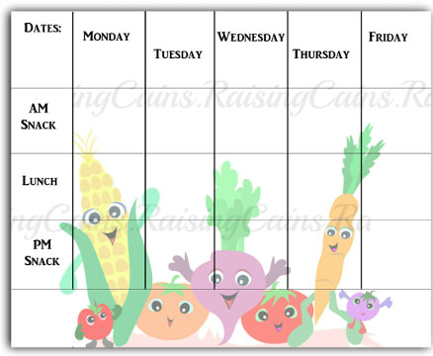
Look around the house for any leaflets or take away menus. What price is the food? Can you do any meal deals?

Designing a school menu. Can you design a new school menu? What could you add? What would you keep the same? Will it be a healthy school menu? Can you find pictures or draw pictures to add to your menu? Plan out your menu and remember to include prices.
Will you have a different menu every day or will some things be available all the time?

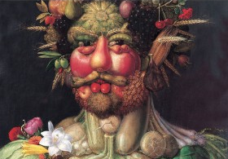
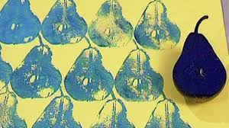
Cooking: find a few recipes and check if you have the ingredients at home and cook a meal for your family. Think about a starter, main and dessert. Can you cook as a family? Who will do the measuring?

Fruit survey: Ask people in your family their top 3 favourite fruits they like to eat. Collect the information and add it to your tally chart. Can you represent this information in a bar chart? You could make one on the computer here!

Fruit and vegetables printing: Look at the work of the artist: Lynn Flavell. How does she represent fruit and vegetables? Can you create a piece of artwork in the style of Lynn Flavell. Potatoes and apples are particularly good for printing. If you don’t have paint or don’t want to us food, why don’t you draw a still-life picture of a piece of fruit? Here is a video to show you how!

Look at the work of Giuseppe Arcimboldo.
Using different drawing materials, can you create a picture of your own?
Additional learning resources parents may wish to engage with
White Rose Maths – These packs will be able to take you and your child step by step through different mathematical concepts!
Classroom Secrets Learning Packs - These packs are split into different year groups and include activities linked to reading, writing, maths and practical ideas you can do around the home.
Twinkl - to access these resources click on the link and sign up using your own email address and creating your own password. Use the offer code UKTWINKLHELPS.
Headteacherchat - This is a blog that has links to various learning platforms. Lots of these are free to access.
#TheLearningProjects

