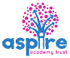
Learning Project - Around the World
WK 12 Online
Age Range: Y3/4
Weekly Reading Tasks | Weekly Spelling Tasks
Monday- Share a story together, perhaps a story from another culture? Ask your child to identify any countries, cultures or food that are referenced in the story. | Monday- Your child can learn to spell the continents of the world. Practise writing them using pencils, pens, chalk, sticks, typing, etc.
Tuesday- Visit Ducksters and let your child choose a region to learn about. Ask them to identify major cities, rivers and information on its landscape. | Tuesday- Practise spelling these words: sadly, completely, usually, finally, comically. Can your child identify the spelling rule for adding the ‘ly’ suffix? Spelling Frame
Wednesday- Can your child design a book cover for a well-known myth e.g. Romulus and Remus? Or can they write an alternative ending instead? | Wednesday- Can your child create their very own ‘Around the World’ crossword puzzle? Crossword maker Help them write clues and a family member can complete it.
Thursday- Visit Story Nory and let your child choose a story from around the world to listen to. Can they summarise the main events by drawing a comic strip? | Thursday- Trace it. Choose 5 Common Exception words and trace around each word. What does your child notice about the shape of each word?
Friday- Look at this world flag poster together. How many flags does your child recognise? Ask your child to choose one of the countries and read online about their culture, cuisine, popular sport and significant/famous people from this country. | Friday- Ask your child to list adjectives and place names that begin with the same letter e.g. fascinating France, sweltering Sri Lanka, exquisite England. Can they put these into a list poem? Writing a List Poem: Did you know a list can be poetic? A list poem features list of people, places, things, or ideas organized in a special way. The title says what the list is about. It does not necessarily need to include rhythm or rhyme, but each word should be carefully chosen and memorable. Check out this list poem: What's in the box under my bed?  eight marbles and a shoestring  a shiny bubblegum ring  two valuable baseball cards  some chocolate candy bars  a letter my friend wrote
Weekly Writing Tasks | Weekly Maths Tasks- Multiplication and Division  Choose a task or tasks from each day. These are to be used flexibly
Monday- Visit the Literacy Shed for this wonderful resource on The Blackhat. Or your child could design a new island for people to visit by creating a detailed map from a bird’s eye view. | Monday- Choosing a times table of choice, ask your child to write a rap/song to help them remember the multiplication facts linked to this time table. Can they include the corresponding division facts in their rap/song too?  White Rose Maths online daily maths lesson  Bitesize Maths online daily maths lesson  CODE Maths Hub Daily Fluency Activities - Day 1 Week 7
Tuesday- Ask your child to write a set of instructions explaining how to make an African mask. Remind them to include: equipment, headings, imperative verbs (bossy words), adverbs (e.g. carefully, slowly) and a handy hint.  how to make a mask | Tuesday- Practise your multiplication skills by creating your own practice grids like the ones below or complete the attached sheets to practise your skills.  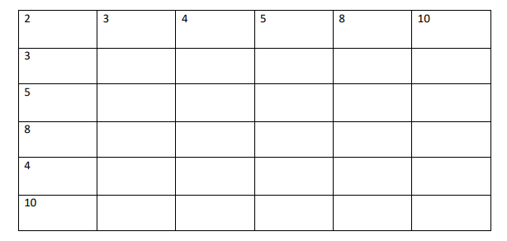  White Rose Maths online daily maths lesson  Bitesize Maths online daily maths lesson  CODE Maths Hub Daily Fluency Activities - Day 2 Week 7
Wednesday- Discuss a holiday that your child has been on or a place they’ve visited. Get them to design a postcard and write about what they did there. | Wednesday-  Practise your division skills by doing this activity.  Select a target table or possibly 2.  Write down all of the multiples up to the 12th multiple.  For example the multiples in the 8x table would be 8,16,24,32,40,48,56,64,72,80,88,96  Put the cards face down and then pick up 1.  Then write the division calculation which matches the multiple for example  40 ÷ 8 = 5  88 ÷ 8 = 11  48 ÷ 8 = 6  You may way to have 2 different sheets if practising the facts for more than 1 table  Play this game to practise your division skills  White Rose Maths online daily maths lesson  Bitesize Maths online daily maths lesson  CODE Maths Hub Daily Fluency Activities - Day 3 Week 7
Thursday- Get your child to listen to some Anansi stories. Ask them to write their own story featuring Anansi. What is she going to teach them? Encourage them to create their own book with a front and back cover and illustrations. | Thursday -  Using playing cards or digit cards 1 – 9 practise your multiplication skills.  Y3 Pick up 3 cards and organise them like this ( 2 digits by 1 digit )  26  x 3  Y3 In the first instance, practise multiplying by 2,3,4, 5 or 8 first  Y4 -  As above but pick up 4 cards (3 digits by 1 digit)  White Rose Maths online daily maths lesson  Bitesize Maths online daily maths lesson  CODE Maths Hub Daily Fluency Activities - Day 4 Week 7
Friday- After the reading task, your child can create an information report on their chosen country and organise their paragraphs using these headings: culture, cuisine, popular sport and significant/famous people. This video might help | Friday (theme)-  Complete the Maths Challenges based on Around the World in 80 days by the cyclist Mark Beaumont. These can be found on Twinkl website.  White Rose Maths online daily maths lesson  Bitesize Maths online daily maths lesson  CODE Maths Hub Daily Fluency Activities - Day 5 Week 7

Learning Project - to be done throughout the week
The project this week aims to provide opportunities for your child to learn more about countries and cities around the world. Learning may focus on different cultures and traditions, famous landmarks, food and clothing.

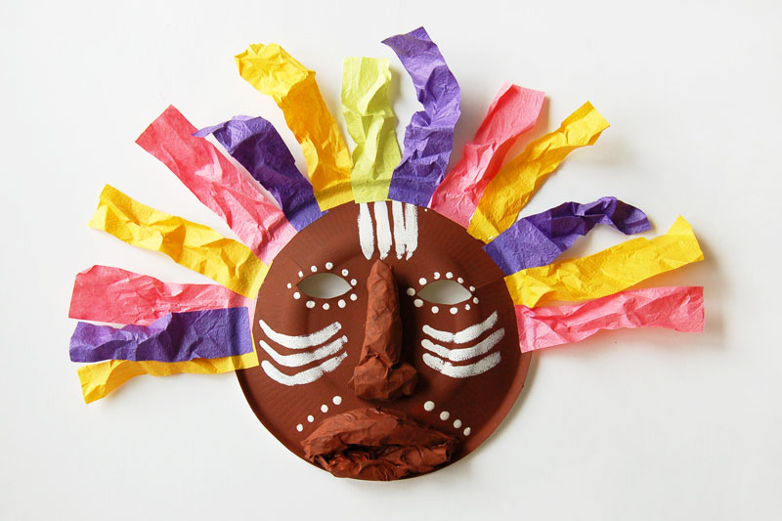
- Virtual Explorer - What are the continents of the world? Where are they located? What languages are spoken in these continents? Ask your child to use Google Maps to explore a continent of their choice. Can they create a continent fact file or choose a particular country they are interested in and create an information guide including the weather, tourist locations, landmarks, weather, traditional music, food and flags. Remember to tweet a photo of their fact file or information guide #TheLearningProjects.

- Mask Making - Ask your child to use paper or cardboard and a range of materials around the home to design and create their own African mask. Can they find out their importance to African culture by watching this clip?

- Dance Around the World - Use SafeYoutube to dance along to some different cultural dances from around the world, such as the Brazilian Samba, the traditional Diwali stick dance or the Spanish Flamenco. Your child can design a cultural costume for their favourite dance and label it with suitable materials. Why not record a video to share with your school’s Twitter? Encourage your child to watch the recording back and evaluate their dance. Recommendation at least 2 hours of exercise a week.

- Speak the Language - Encourage your child to discuss with their family the links they and their family have to the wider world. Find out places family members have visited on holiday, work/business links or simply countries they would like to visit in the future. Have a go at learning some simple phrases in different languages from around the world and write the phrases using the colours of the flag for that country. You could visit the Mrs Mandarin website here.

- Tribal Traditions - Ask your child to find out about the cultural differences, customs and traditions of an indigenous group/tribe from around the world such as the Maori people, Native Americans, the Yanomami tribe or the African Maasai tribe. Ask your child, why it is important indigenous people are remembered? Can your child create some artwork inspired by one of the tribes? This link might help you
Mindfulness
Find a safe space where you can lie down quietly with your eyes closed for a few minutes (this is a lovely activity to do outside if the weather is good). Get comfortable and take a few deep breaths to relax your body. Imagine you are on a magic carpet that can fly anywhere in the world. Where would you like to go? Imagine how it feels as the magic carpet lifts you off the ground and up into the sky. Can you feel the wind on your skin, hear the birds flying past or sense damp clouds moving around you? Imagine how this feeling changes as the magic carpet flies back down closer to the ground near your chosen destination. You are now looking down over the edge of the carpet. What can you see? What can you hear? How does it make you feel?
Continue to take slow, deep breaths as you carry on your magical journey for as long as you like.
STEM Learning Opportunities #sciencefromhome
Engineering Around the World – World’s Tallest Tower
- In 2020 the new world’s largest tower will be the Jeddah Tower, in Saudi Arabia. It will have 200 floors and will the reach 1008 meters high.
- Use scrap paper and junk box materials to build a tower. You might like to search for photos of the ‘Jeddah Tower’ to help you with your design.
- What is the tallest tower you can build?
Additional learning resources parents may wish to engage with
- BBC Bitesize - Lots of videos and learning opportunities for all subjects.
- Classroom Secrets Learning Packs - Reading, writing and maths activities for different ages.
- Twinkl - Click on the link and sign up using your email address and creating a password.
- White Rose Maths online maths lessons.
- Times Table Rockstars and Numbots. Your child can access both of these programmes with their school logins. On Times Table Rockstars, children should aim to play Soundcheck for 20 minutes daily.
- Sumdog
- IXL online. Click here for Year 3 or here for Year 4. There are interactive games to play and guides for parents.
- Y3 Talk for Writing Home-school Booklets and Y4 are an excellent resource to support your child’s speaking and listening, reading and writing skills.
The Learning Projects are based on the National Curriculum expectations for the key stage which your child is in. It may be that your child finds the tasks set within the Learning Project for their year group too simple. If this is the case, then we suggest that your child accesses the Learning Projects which are set for the key stage above. Equally, if the projects are too challenging, then we advise that your child accesses the projects for the key stage below.
If your child requires more of a challenge, or you believe that there are some gaps in their learning then Century Tech is a fantastic resource that is currently free for home learning. The app is designed to address gaps and misconceptions, provide challenge and enables children to retain new knowledge. It uses artificial intelligence to tailor the learning to your child’s needs. Sign up here.
#TheLearningProjects
in collaboration with
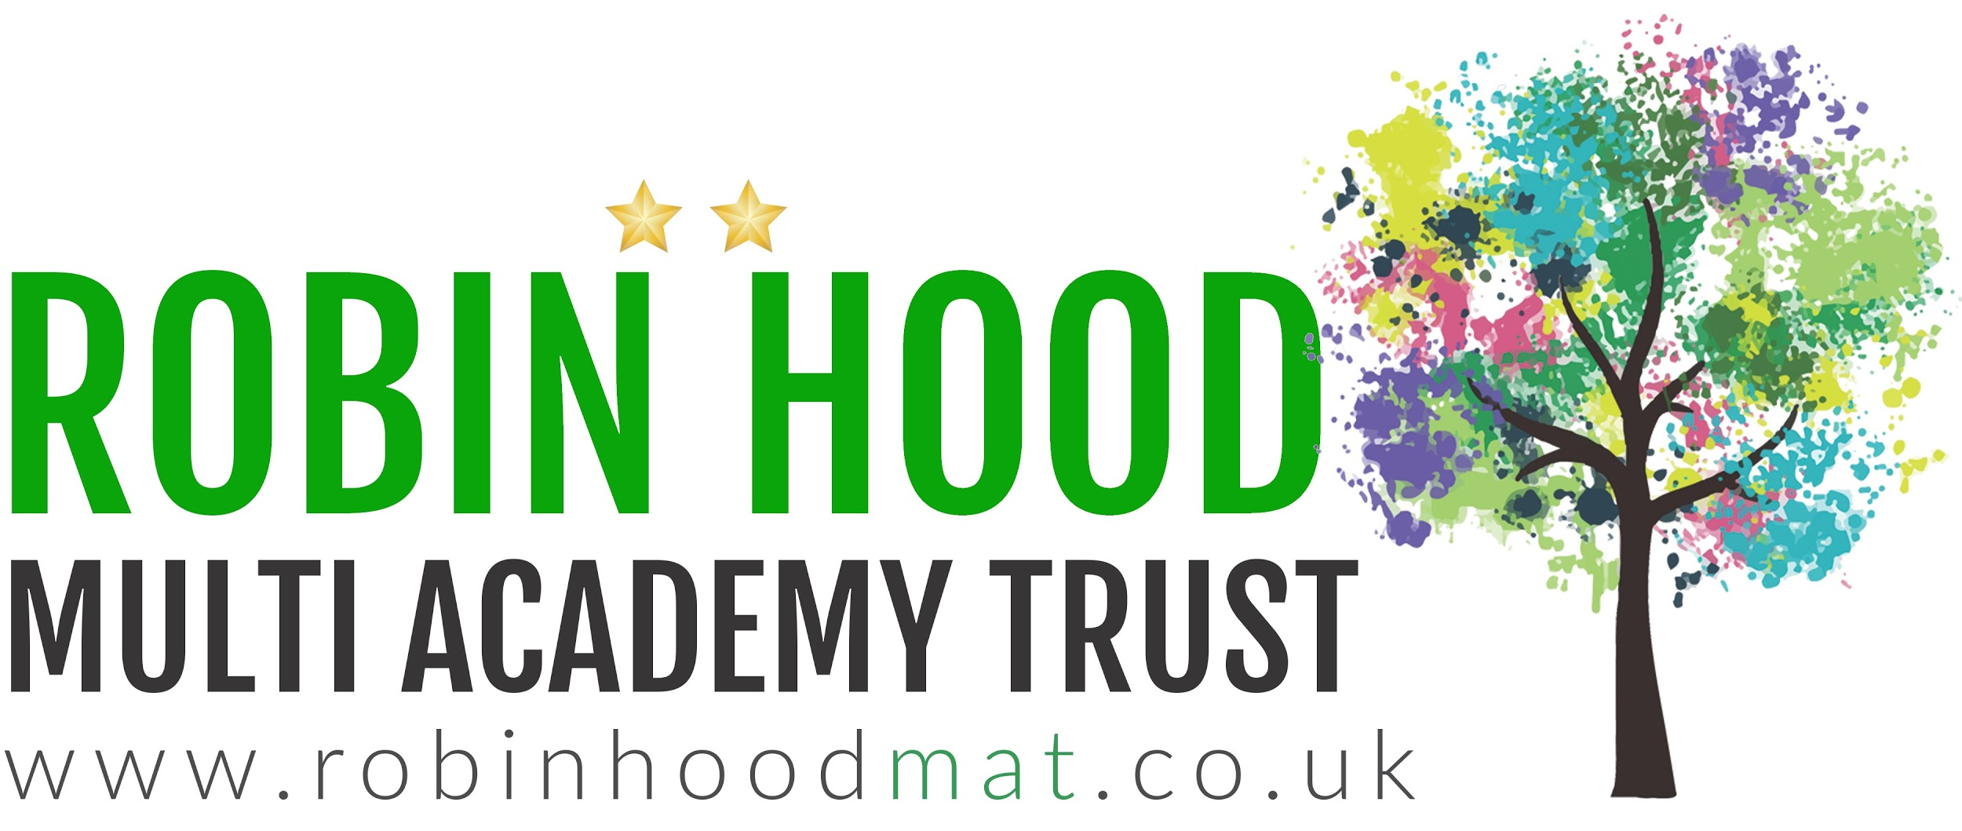
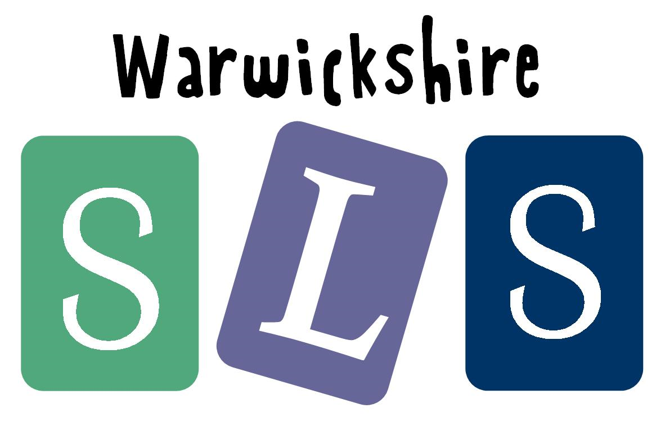
www.robinhoodMAT.co.uk

