Learning Project WEEK 7- Celebrations Online
Age Range: EYFS
Weekly Maths Tasks (Aim to do 1 per day)
- Watch a Numberblocks clip each day at: BBC or CBeebies. Use this guide here to give you ideas on what to do with your children whilst watching an episode.

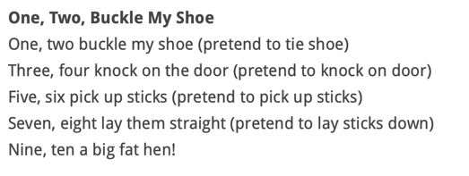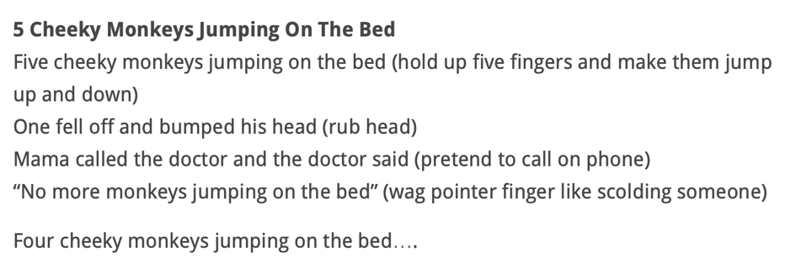

Every morning sing the Days of the Week Song - Sing to the tune of Alouette – change the day on each new day.

Monday, Tuesday, Wednesday, Thursday, Friday, Saturday, Sunday, the week has seven days, today is (day in here e.g. Monday), (day again e.g. Monday), (day again e.g. Monday), today is (day in here Monday) all day long.

- Working on Numbots - your child will have an individual login to access this.

- Play this game to practise counting, ordering and matching numbers to 10.

- Practise counting up to 20. This can be done through playing hide and seek, singing number songs, chanting, board games etc.
Counting : What is the rule about counting? We count everything once and we stop when we have done so. The last number we say tells us how many we have (the quantity). You will need a tin or cup and a collection of small toys, buttons or stones.
Drop 4 stones into the tin one at a time, while your child listens carefully. Ask how many they think are inside the tin? Why do they think that? How sure are they? Tip the tin out and check. This game can be varied by dropping irregularly, or by using quieter objects. Later when they get good at this, ask “How many is that so far inside?” and then dropping two more on top of the original amount, supporting the child in counting on from a small amount: “Four.... Five, six.” The important idea is to draw their attention to the last number we say telling us how many there are.
What’s missing? You will need 6 pieces of paper and a collection of small bricks, stones, buttons or similar. Clearly write the numbers 0,1,2,3,4,5; one on each piece of card. Together with your child, organise the 0 – 5 number cards in order from the smallest (0) to the largest (5) number. Take it in turns to hide your eyes whilst the other player turns a card over (or removes a card and closes the gap – harder!). Player one opens their eyes and works out which number is missing.
To extend this, you could shuffle the cards around after removing one or play with numbers 0 to 9. But remember it is best to begin any game at a slightly easier level than you think your child can manage. It is easy to introduce a challenge with their agreement! You could match an amount of bricks to each number, and play the hiding game by removing one brick – what has changed? How do you know?
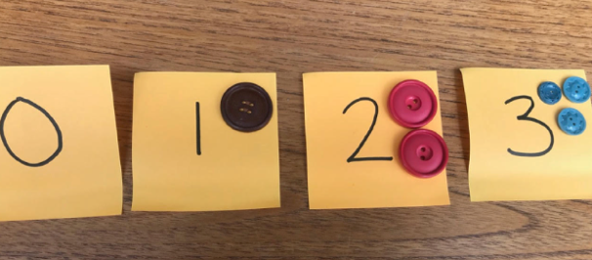
- Listen to a number song from the CBeebies website. After listening to them, watch again and sing along if you can. Talk about the maths you can see in the video clip.

Make a selection of birthday cards with numerals on the front. Can your child count out birthday candles (if you have them available) or objects to match the amount? Can they order the numerals from the smallest amount to the largest?

Draw a large hopscotch grid or use masking tape on the floor for you and your child to jump along,
show them how to play. Create a diagram with ten sections and number them.
Each player has a marker such as a stone, bottlecap, shell, button, etc.
For younger children simply hopping across the single versus double squares can provide hours of fun. The first player stands behind the starting line to toss his or her marker in square one. Hop over square one to square two and then continue hopping to square ten, turn around, and hop back again. Pause in square two to pick up the marker, hop in square one, and out. Then continue by tossing the stone in square two. All hopping is done on one foot unless the hopscotch design is such that two squares are side-by-side. Then two feet can be placed down with one in each square. A player must always hop over any square where a maker has been placed. Getting out: A player is out if the marker fails to land in the proper square, the hopper steps on a line, the hopper loses balance when bending over to pick up the marker and puts a second hand or foot down, the hopper goes into a square where a marker is, or if a player puts two feet down in a single box. The player puts the marker in the square where he or she will resume playing on the next turn, and the next player begins.
White Rose Weekly Maths White Rose Maths -click for Summer Term guidance.

Weekly Phonics Tasks (Aim to do 1 per day) | Weekly Reading Tasks (Aim to do 1 per day)
Sing Nursery Rhymes and songs together. Add in actions and change the words. Can children think of different rhyming words to add in? Repeat old favourites and learn new rhymes. You can find an A-Z of Nursery Rhymes.  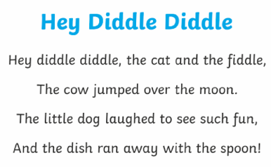  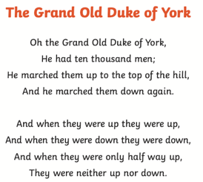  Daily phonics - Practice the sounds your child is working on and blend words. This can be oral blending (e.g. Fred Talk c-a-t) or written if appropriate. Please visit https://www.ruthmiskin.com/en/find-out-more/parents/ for more information and support.  Interactive games.  - Watch a video of a fireworks display. Can your child explore using instruments (if available) or household objects e.g. pots and pans to make their own imitation of firework sounds.  - Learn the song ‘On Bonfire Night’ and encourage your child to make marks to represent the sounds in the song e.g. whiz, whiz could be a swirling pattern.  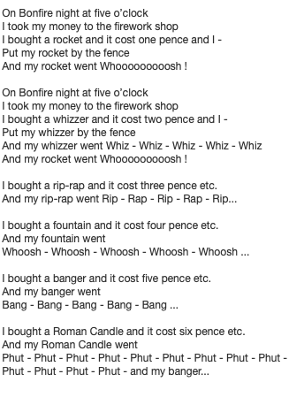 | Read a variety of books at home. Favourites can be repeated. Hearing the patterns of language in a story will support your child’s language development.  Reception age children: Children to read to parents daily. Visit Oxford Owl for free eBooks that link to your child’s book band. You can create a free account.  Complete the linked Play activities for each book.  With your child, look in magazines, newspapers and books for the tricky words (red words) they are currently learning. They could use a highlighter to highlight in magazines and newspapers.  Use the Small Talk website for ideas on supporting your child’s Communication and Language development.
 | Weekly Writing Tasks (Aim to do 1 per day)
Practice name writing. Can they write their first name? Middle name? Surname?

Practice forming the letters of the alphabet. Follow your school’s script.

Ask your child to write out the tricky words (red words) they are working on at the moment on pieces of paper and turn them into a pairs game.

Create a card for a celebration of your choice. Can your child use their phonics knowledge to write a message for the person they would like to give it to?

Ask your child to draw a picture of a celebration they have taken part in. Encourage them to use their phonics knowledge to write simples sentences about their memory of that day. Remind your child where to start on the page, starting with a capital letter, finger spaces and a full stop. Make a high frequency word mat for your child to use.

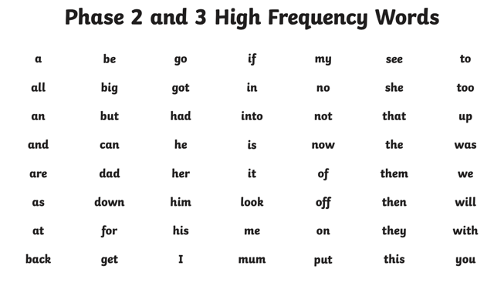
Learning Project - to be done throughout the week
This project this week aims to provide opportunities for your child to learn more about celebrations. Learning may focus and different types of celebrations that take place and who may celebrate them. It could look at how people celebrate different events differently in other parts of the world.
- Family Photographs-
  - Look over a selection of photographs of family celebrations and discuss with your child: what the celebration was about, who attended, what you did to celebrate, when it took place, whether it is an event that happens each year. Can your child remember the event taking place? What do they remember of it?
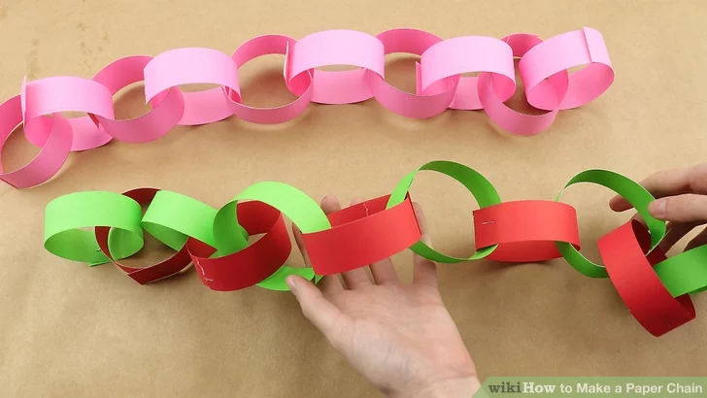
- Plan a family celebration-
  - Decide on a family celebration for the week. This could be a family indoor picnic, meal, dance etc. Ask your child to write invitations to family members to the party.
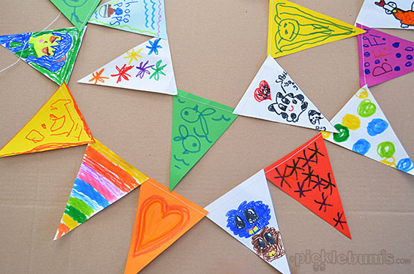
  - Create homemade decorations using coloured paper (If you do not have coloured paper at home, you could use old newspaper or wrapping paper) You could make paper chains or bunting
  - Plan a menu for the party and make the food together.

- Discover religious celebrations-
  - Watch the Let’s Celebrate video collection for Easter. Discuss the celebrations with your child. Did they celebrate Easter? Which of the events did they take part in?

  - Watch the Let’s Celebrate video collection for Eid-al-Fitr. Discuss the celebrations with your child. Did they celebrate Eid-al-Fitr? How did they celebrate? Are there any similarities and differences between the celebrations they saw in the Easter videos?

  - Look through the range of videos available on Cbeebies and watch together. Discuss who celebrates the event and any similarities and differences with celebrations your child has taken part in.

Mindfulness – Balance the toy!
Helping your child to have some focused mindfulness time is a great way to help them cope with any difficult feelings or emotions so over the next few weeks we will be offering some techniques to try.

Help your child to find a soft toy (it will need to be something that will balance on their body, so make sure it’s not too big or heavy!). Explain to your child that they should lie down on their back with their legs stretched out straight and their arms straight down by their sides. Tell them you are going to balance the toy on their tummy, and they need to stay still so that it doesn’t fall off. Explain this is a quiet time when you are both going to focus on your breathing because it’s a great way to keep your brain and body healthy. Ask your child to take big slow breaths. Can they feel their toy moving up and down? Encourage them to keep quiet and still, with just their belly moving up and down as they continue to focus on taking long, slow breaths. Keep going until you sense your child is getting restless. You could try doing this a few times throughout the week. You can use different toys to maintain your child’s interest. You could add some gentle music to relax to.

- Birthdays-
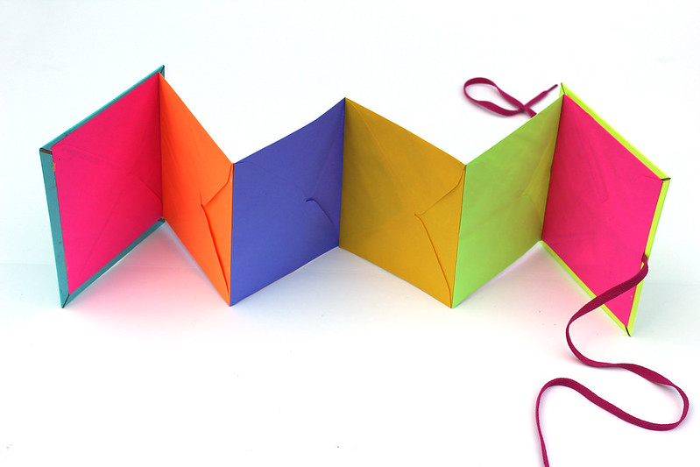
  - Talk to your child about when they were born. Look at photographs of the day they were born, if you have them available. Do they know the date of their birthday? Support your child to create an all about me folding book (as pictured) with their birth date, current age and anything else they think is important for people to know about them.
Additional learning resources parents may wish to engage with
Classroom Secrets Learning Packs - These packs are split into different year groups and include activities linked to reading, writing, maths and practical ideas you can do around the home.
Twinkl - to access these resources click on the link and sign up using your own email address and creating your own password. Use the offer code UKTWINKLHELPS.
Headteacherchat - This is a blog that has links to various learning platforms. Lots of these are free to access.
White Rose Weekly Maths White Rose Maths -click for Summer Term guidance.
#TheLearningProjects

