Mawgan-in-Pydar
Newsletter
19th June 2020

Thank you – We Miss you!
Once again, I’d like to express my huge thanks to you all for your patience, understanding and support over the last few months. This is a totally unprecedented situation that no one ever imagined, I’m sure. The many kind words expressed, emails sent and even treats for staff made by children who are not able to be in school have really meant a lot to us. Thank you!
Whilst we are providing provision for our keyworker pupils in school, those pupils who are not in school continue to be very much in our minds. Work in school is linked with work set for home learning, any new displays going up contain work done by children at home as well which they have shared on Google Classroom and teachers frequently share with their ‘pods’ in school, pupils work from home. We really do enjoy seeing work that has been done, whether it be learning about germs, art work – designing logos, videos about pets, bioluminescent jelly fish, feel good collages, journey sticks, garden designs, home-made go-carts etc. The staff are working tirelessly to try and combine learning in school with home learning, aiming to keep our learning community as cohesive as possible in this new way of working.

Pupil Well-Being Communication
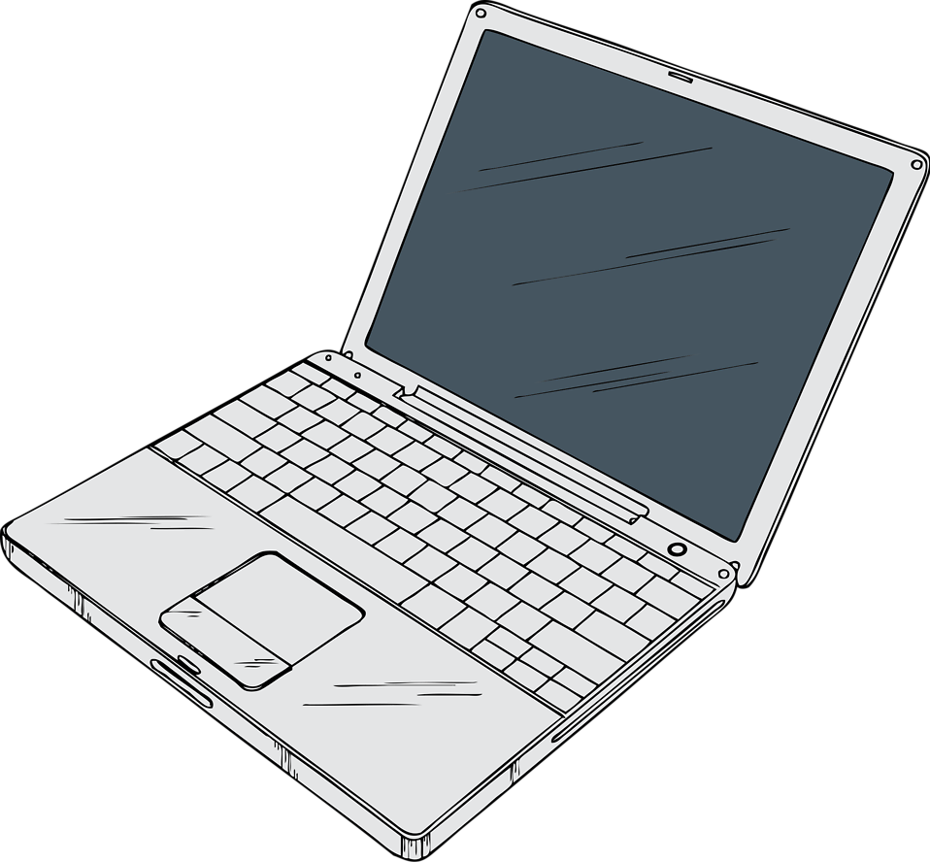
As we continue to move forwards within these strange circumstances, we have been exploring alternative ways to engage with our pupils at home. Next week information will be shared regarding the use of Microsoft Teams for pupil well-being communications. We will trial this initially with our eldest pupils and if it works then we will try to communicate with all year groups over the coming weeks. Please keep an eye out for information regarding this. Safeguarding our pupils and staff has to be at the forefront of the decisions we make.

Good News - Mrs Wicks and Mr Wellstead
I am delighted to inform you that both Mrs Wicks and Mr Wellstead will be remaining with us next year. They are both very skilled teachers who add a wealth of experience to our team. Mrs Wicks will also be taking on the role of SENDCo for us from September.

Get Well Soon Mrs Cooper
Some of you may have heard that Gill had a cycling accident a couple of weeks ago. Gill has hurt her shoulder and collar bone quite badly and is mostly working from home at the moment. She is doing her best, ably supported by the other Mrs Cooper, to reply to emails and continue to get information to you. Thank you for your patience!
Joe Wicks
Yesterday Mawgan-in-Pydar school got a special mention on Joe Wicks’ daily ‘PE with Joe’ session thanks to George and his dad. Check out our Twitter feed and facebook page for the link.
Cornwall Virtual School Games
We are all very excited about the upcoming virtual games, starting on Monday 22nd June. All the information you need is on our website, Google Classroom and the @CornwallSchoolGames facebook page. We have registered as a school so you don’t need to register individually. We will make available the link to upload daily results from home next week. Please join us in our quest for Gold! Every little helps!
Dates for the diary
We will officially break up for the Summer holidays on Thursday 23rd July 2020.
We are due to return for the Autumn term on Monday 7th September.

