W/C 18.05.2020: Learning Project - Under the Sea Online
Age Range: EYFS
Weekly Reading Tasks | Weekly Phonics Tasks
Monday- Share the story ‘The Snail and the Whale’. If you don’t have a copy at home read this adapted version here or here online and then you can watch it at BBC iPlayer. Adapted version also at end of this document.  Practise reading the following key words: this, the, and, snail, whale, swim, go, rock, ocean, storm.  Write them onto flash cards to use at home. | Monday- Ask your child if they can hear the sounds that come at the beginning of snail and whale. Can they think of/ or find other things that begin with the same sound? They could create a poster or take photographs of the things they see.  Daily Phonics - Practice the sounds your child is working on and blend words. This can be oral blending (e.g. Fred Talk c-a-t) or written if appropriate. Please visit https://www.ruthmiskin.com/en/find-out-more/parents/ for more information and support.
Tuesday- Reception age children read together ‘The Snail and Whale’. Children to read to parents daily. Visit Oxford Owl for free eBooks that link to your child’s book band. You can create a free account. Complete the linked Play Activities for each book.  Read keywords for this week (see Monday). | Tuesday- Buried Treasure: Write out some real words and made up words (e.g. tud, jup, fub). Place these in a pile and using 2 containers, label one as ‘Treasure’ and the other as ‘Bin’. Can your child read the word and decide if it is real? If it is real it goes in the treasure chest, if not it goes in the bin. Simplify this activity for Nursery by sounding the words out for them.  Daily Phonics (see Monday).
Wednesday- Read a variety of books at home in different places. Favourites can be repeated. Hearing the patterns of language in a story will support your child’s language development.  Read keywords for this week (see Monday). | Wednesday- Play Buried Treasure online on PhonicsPlay.  Daily Phonics (see Monday).
Thursday- Read ‘The Snail and the Whale’. Can you support your child to think of their own story about a snail going for a ride on an elephant or a bird?  Read keywords for this week (see Monday). | Thursday- Sing ‘1,2,3,4,5 Once I caught a fish alive’. Can your child learn this by heart?  Daily Phonics (see Monday)  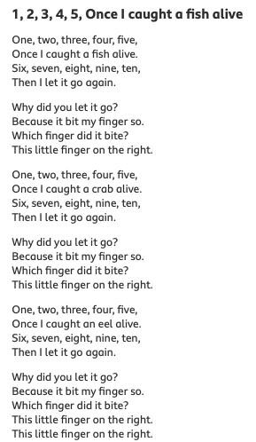
Friday- Ask your child to look at the books you have in your house. Can they find any other books about creatures that live under the sea? Can they group the animal books e.g. farm animals, jungle animals, under the sea animals?  Look at the similarities and differences between the Fiction Books (story) and the Non-Fiction books (information and fact books).  Read keywords for this week (see Monday). | Friday- Play Fish for Sounds – write out some letter sounds that correspond to objects associated with the sea or going to the beach – sh for shell, f for fish. Try and write them outside in chalk or similar and encourage your child to trace over them.  sh-shell, s- sea, f-fish, w-wave, o-ocean, b-boat, s-sand, l-lollipop, h-hot, f-flippers, p-puffin, t-towel, j-jellyfish, n-net  Daily Phonics (see Monday)
Weekly Writing Tasks | Weekly Maths Tasks- Making Simple Patterns
Monday- Ask your child to draw a picture and write about their favourite underwater creature. Support your child to use their phonic knowledge to label the picture too. | Monday - Thinking about positional language – ‘next to, by the side, rigt, left, above, underneath etc.  Task four: Make it the same You will need a book to act as a screen between the two of you and two identical sets of bricks or blocks (not too many) and perhaps a toy car and a play person. Share these out between the two of you to make sure you each have the same collection. One person builds a small scene with their bricks and toys, secretly, behind the screen. When they are ready, they tell the other person how to make one exactly the same as theirs. Only they are allowed to look over the screen to see how the builder is doing (and correct them if necessary). You can only touch your own bricks. When they think it is the same, remove the screen. Examine what is different – or not. Then swap roles! These tasks are meant to be playful and to be enjoyed together. When your child asks to repeat one you know you are winning. Aim for that!
Tuesday- Have a try at Snail Writing. Using hair gel, shaving foam or any other slimy liquid, show your child how to form the letter ‘s’ using your finger. If your child can, ask them to try the word ‘snail’. Repeat for other words from the story. | Tuesday-  Sing to the tune of ‘Bobby Shafto’  Clap your hands and wiggle your fingers  Clap your hands and wiggle your fingers  Clap your hands and wiggle your fingers  Now we’ve made a pattern.  Tap your knees & blink your eyelids  Tap your knees & blink your eyelids  Tap your knees & blink your eyelids  Now we’ve made a pattern.  Repeat with other actions for as long as you wish!  Can your child join in with tongue twisters: red lorry, yellow lorry, red lorry, yellow lorry?  Ask your child to make a simple pattern or a colour pattern using beads or other objects – start with 2 colours, Can you describe the pattern to each other? For example  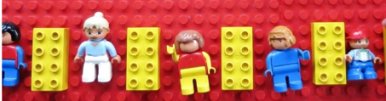  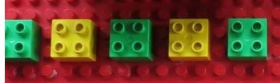  CHALLENGE: Make your own repeating pattern or patterns
Wednesday- Talk about postcards when would we send them? Ask your child to write a postcard from the snail. What would the snail write to his friends about his adventure? Write a postcard to the snail’s friends from the Snail. | Wednesday- Can your child make a repeating pattern using objects around the house/garden i.e. apple, banana, apple, banana. CHALLENGE: Ask your child to build on the above to create more complex patterns e.g. apple, apple, banana, apple, apple, banana.  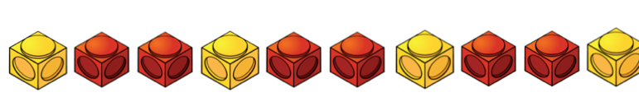 or 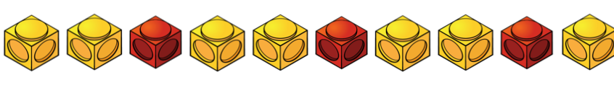  Or  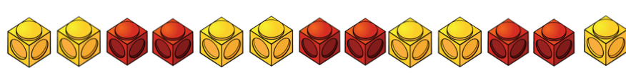  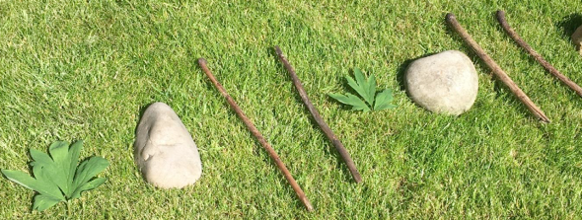
Thursday- Practise letter formation - handwriting.  CHALLENGE- Can your child write a simple letter from the snail to the class teacher in the story asking for help of the whale. | Thursday- Ask your child to create repeating patterns with actions: Clap hands, tap knees, clap hands, tap knees. Make your own action patterns. Next one person makes the action pattern, the other person is to listen and repeat CHALLENGE: Continue a pattern which ends mid repeat using objects.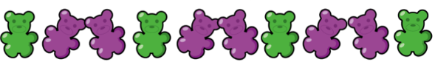
Friday- Write a list of the titles of your books – Fiction (story books) or Non-fiction (Information and fact books). | Friday- On a paper plate or on a circle of paper.  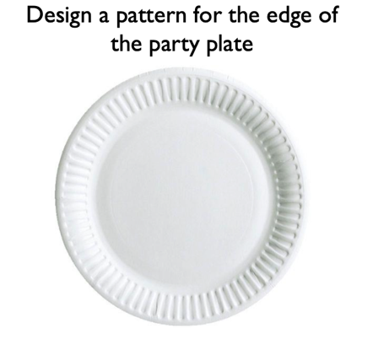

Learning Project - to be done throughout the week
The project this week aims to provide opportunities for your child to learn more about life in and around the sea. Learning may focus on the strange and wonderful creatures and plants that occupy our oceans, their habitats and how human beings affect this environment.

After listening to the story, ‘The Snail and the Whale’ (see reading task).
- Take your child on a snail hunt around the garden or local walk- observing social distancing. Can they think about the places a snail might want to live?
- Show your child the picture of the sea snail.
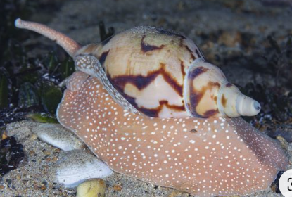

- Ask, how is it different from the snails they found in the garden?
- Have a snail race. Use chalk to draw out lines on the ground (or sticks to mark out the lines) to create a race track. Place your snails at the starting line and watch them go! You could give your child a timer to measure how long it takes for the snails to make their way across. Share a picture of the winning snail on Tapestry.
- 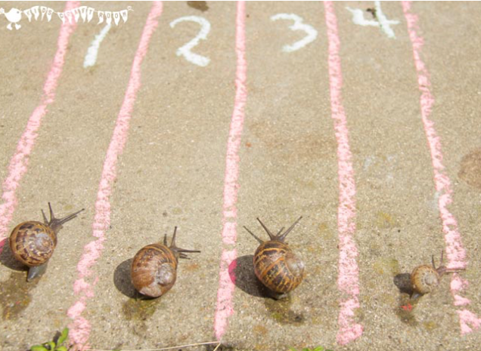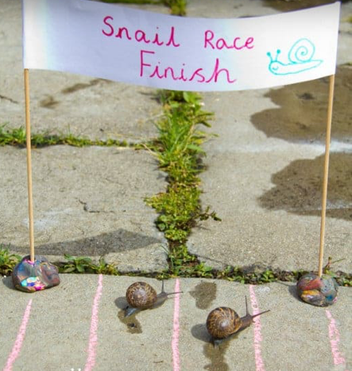
Make your own ‘Under the Sea’ Scene

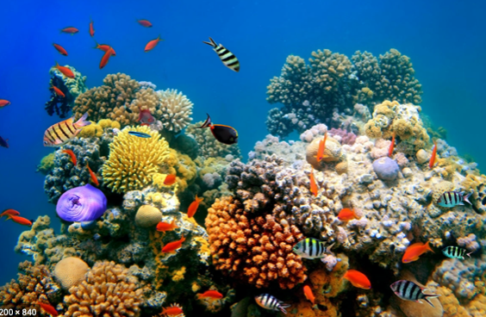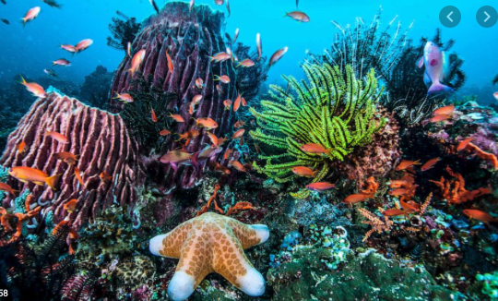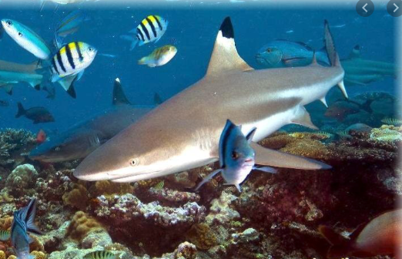
- Look at the picture of the coral reef. Talk about the animals you can see. What are the animals called?
- Use junk modelling or craft items you have around your house to create the scene. You could even add in natural objects e.g. grass as seaweed.
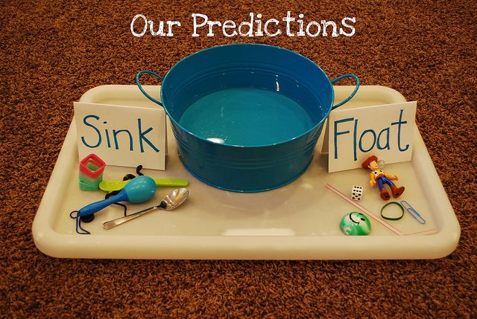
Make your own Fishing Game
- Make a fishing rod using a stick or similar (a wooden spoon would work well!). Tie some string on to one end and tie a magnet onto the end of the string (you could use a fridge magnet).
- Using the rod, your child could explore which items are attracted to the magnet around the house

Explore Floating and Sinking
- Fill up a bowl, sink or basin and provide your child with a range of objects to explore. Which ones float and which sink? Ask them why they think they float/ sink? CHALLENGE: Keep a record of the objects that float and sink? This could be using pictures or written.

Mindfulness
Help your child to choose a piece of instrumental music that they find relaxing. Have them lie down on their back with their eyes closed and both hands on top of their tummy. Ask them to close their eyes and concentrate on their breathing. Can they breathe deep and slow so that they feel their tummy moving up and down under their hands? Ask them to stay like this as the music plays. Just breathing and listening, nice and still. Aim for at least one minute to start with and increase to a slightly longer session each time you do the activity.

Beach safety- Try these excellent resources from the RNLI education team.
https://rnli.org/youth-education/education-resources/lower-primary/copy-of-fly-the-flag
STEM Learning Opportunities #sciencefromhome
- Create a simple under the sea obstacle course or draw an obstacle course on a piece of paper. Children have to guide an under-water robot (Parent/sibling/toy) through the obstacles by shouting out simply instructions. E.g. forwards, right, left, backwards.
Additional learning resources parents may wish to engage with
White Rose Maths online maths lessons. Watch a lesson video and complete the worksheet (can be downloaded and completed digitally).
Numbots. Your child can access this programme with their school login.
IXL Click on Maths, Reception. There are interactive games to play and guides for parents.
Talk for Writing Home-school Booklets are an excellent resource to support your child’s speaking and listening, reading and writing skills.
The Learning Projects are based on the National Curriculum expectations for the key stage which your child is in. It may be that your child finds the tasks set within the Learning Project for their year group too simple. If this is the case, then we suggest that your child accesses the Learning Projects which are set for the key stage above. Equally, if the projects are too challenging, then we advise that your child accesses the projects for the key stage below.

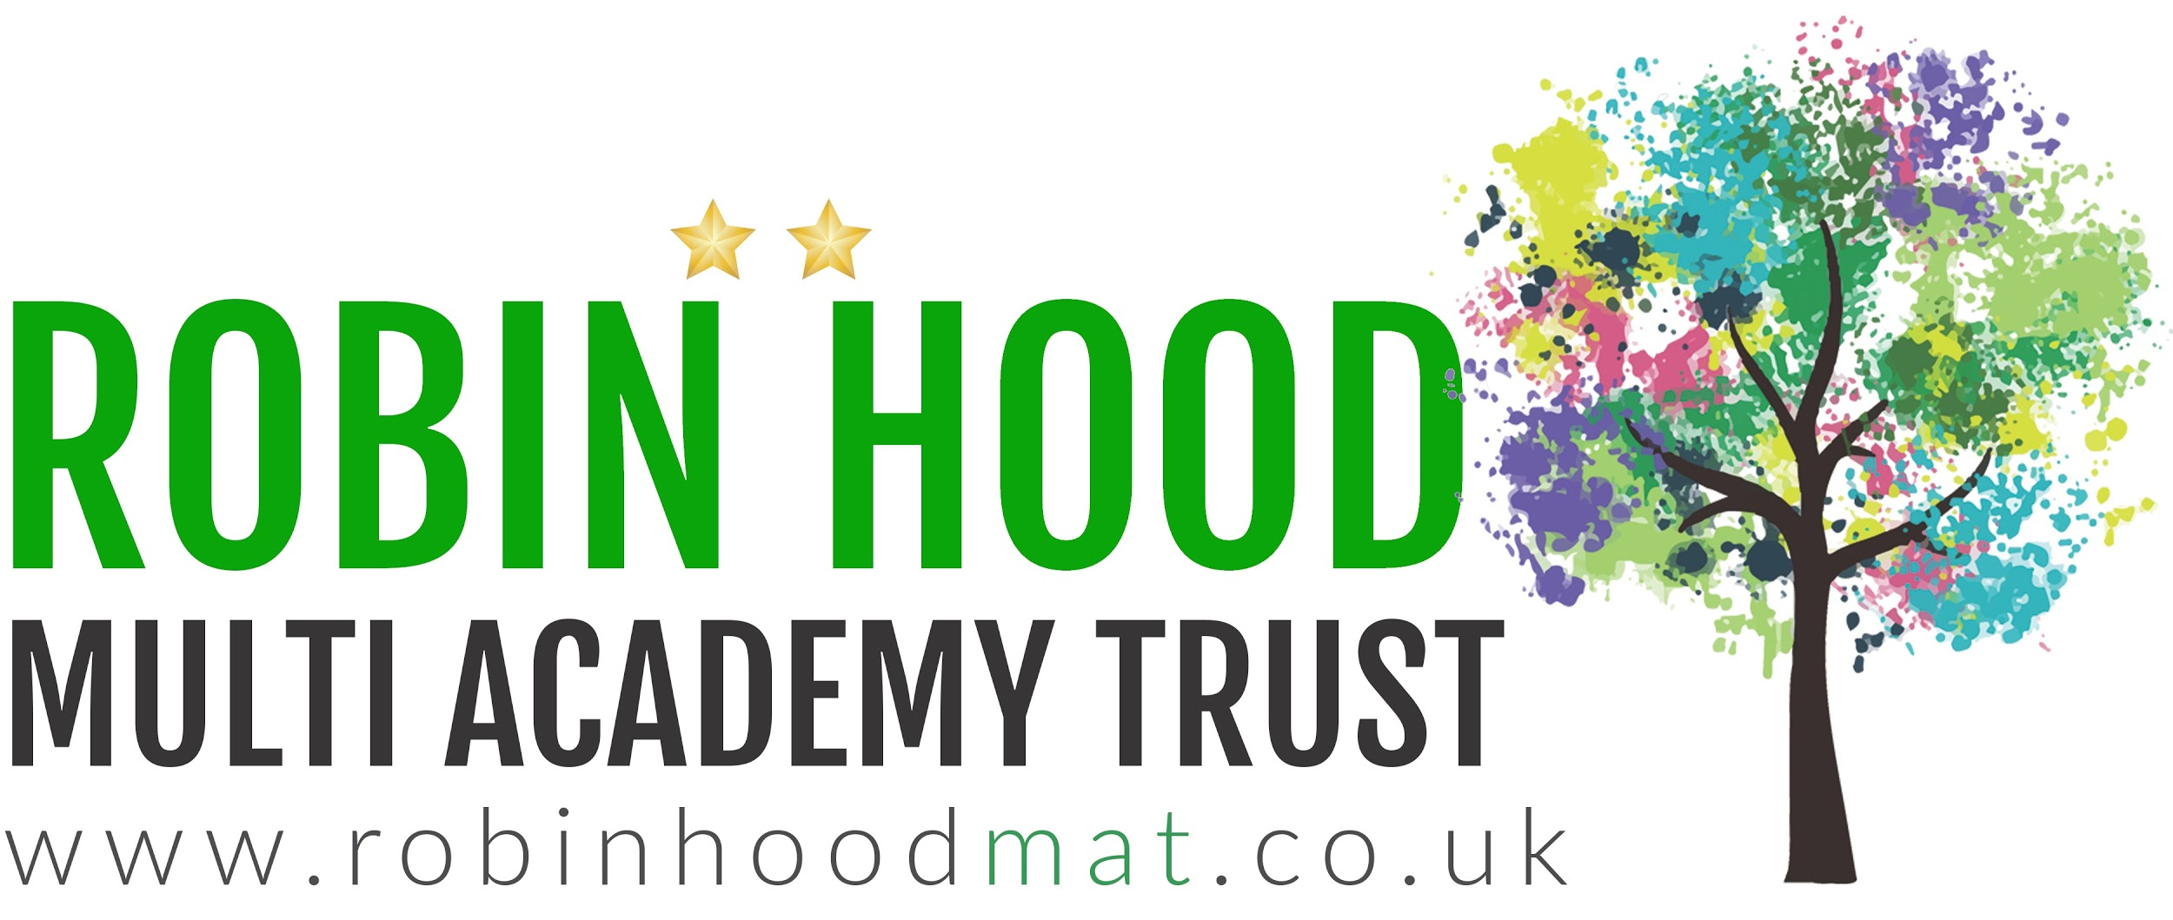
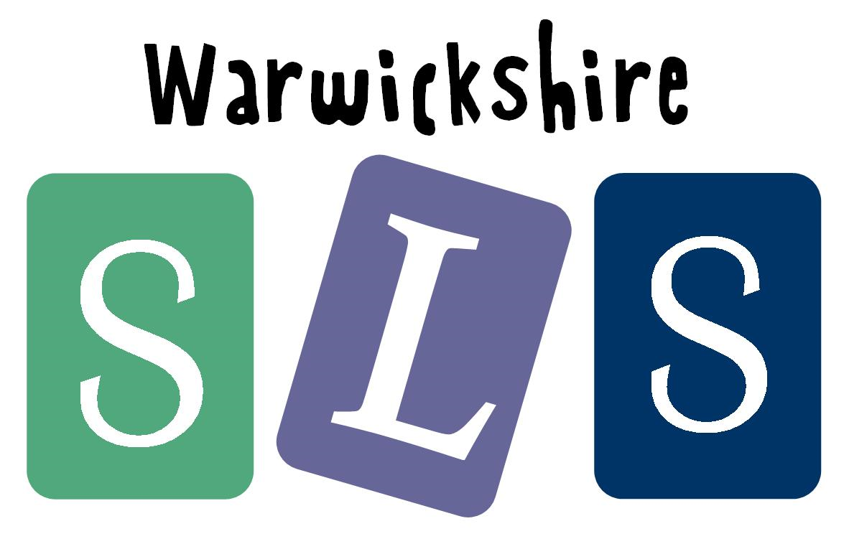
#TheLearningProjects
in collaboration with

