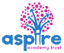
Learning Project - Famous & Significant People
Age Range: KS1
Weekly Reading Tasks | Weekly Phonics Tasks
Monday- Benjamin Zephaniah is a famous poet from Birmingham. Your child can listen to his poem ‘Royal Tea’ here. What did your child like about the poem? What did they dislike about the poem? Could they write their own poem about visiting the queen? | Monday- Choose letters that make words from your spelling list or words that can be read on sight. Write the letters in chalk on the ground outside. Give your child a word and they must spell it by jumping from letter to letter. This could also be done by writing the letters on paper inside the house.
Tuesday- Ask your child to explore and find out about one famous/significant person here. Can they read any tricky words? Why is this person important? Can they create a fact file about this person? What would it feel like to be this person? | Tuesday- Your child could visit this interactive game and play Sentence Substitution.  Weekly spellings: I, you, your, no, go, so, by, my, come, some
Wednesday- Ask your child to re-read their favourite story out loud. Remind them to use expression. Task your child with creating a new book cover for their favourite story or writing an alternative ending! | Wednesday- Mary Seacole and Florence Nightingale are remembered for helping the sick and injured soldiers during the Crimean War. How many adjectives can your child list to describe medical professionals? Can they use these words in sentences?
Thursday- Who was Queen Elizabeth I? Watch this short video and then your child can record what they’ve learned about this royal. They may also wish to use books or websites to help. | Thursday-.‘Kind’, ‘past’, ‘improve’, ‘many’ and ‘people’ are some of the words that children in KS1 need to be able to spell. Can your child use these to write sentences about Mary Seacole or Florence Nightingale?
Friday- Set up an interview where your child can be the interviewer and you can be the famous person (choose from here). Ask them to write down and read back to you some of the things you have said. | Friday- There are live Read Write Inc phonics lessons on YouTube daily. Click here to watch and join in.
Weekly Writing Tasks | Weekly Maths Tasks- Addition  Choose a task or tasks from each day.
Monday- Once your child has listened to ‘Royal Tea’ ask them to create a list of questions that they’d like to ask Benjamin Zephaniah about his visit to the palace. | Monday- Get your child to practise writing their number bonds to or within 10 - e.g. 2 + 7 = 9 or 3 + 4 = 7.  Y1 Play Pairs – number bonds to 10  Create your own digit cards 0 – 10  Place them face down and pick up 2 at a time.  See if you can find the pairs of number which make 10.  As an extra challenge use more than 1 set of cards  Y2  Practise your number bonds to 10 by playing the game above.  As an extra challenge create your own multiples of 10 cards ( 0- 100) to practise your number bonds to 100 i.e. 0 +100 = 100 10 + 90 = 100  White Rose Maths online daily maths lessons  Bitesize Maths online daily maths lessons with worksheets  CODE Maths Hub Daily Fluency Activities - Day 1 Week 6
Tuesday- Ask your child to write their very own royal adventure story. They can write in role as a king, queen, prince, princess, knight or servant. | Tuesday- Get your child to write the number bonds of numbers within 20 especially those of 10 and above.  Then select a number which your child may find it difficult to remember the facts for i.e.  11.  Practise your addition skills up to 20 by playing this game  White Rose Maths online daily maths lessons  Bitesize Maths online daily maths lessons with worksheets  CODE Maths Hub Daily Fluency Activities - Day 2 Week 6
Wednesday- When your child has completed their royal adventure story, they can design a cartoon strip to accompany their writing or a front cover for their story. | Wednesday- Encourage your child to write all of the number facts for  20 e.g. 0 + 20 = 20 progressing up to 20 + 0.  Number Bonds Challenge  Then Create your own digit cards 0 - 20  Pick up a card i.e. 13 and write the number sentence inserting the missing amount  i.e.  13 + 7 = 20.  White Rose Maths online daily maths lessons  Bitesize Maths online daily maths lessons with worksheets  CODE Maths Hub Daily Fluency Activities - Day 3 Week 6
Thursday- Can your child write a letter, postcard or email to their teacher? They may want to describe what they have been doing at home. They might want to tell their teacher about the things that they are missing about school.  You might like to add a message to your google classroom page, so your teacher can read it. | Thursday- Y1 Number Line Add Up  Create your own number line up to 20.  Create your own digit cards 0 – 10.  Pick up 2 cards and practise adding up the 2 amounts using the number line to help you.  i.e. 16 + 4 = 20.  Do this practically at first and record your calculations.  Y2 Play Add Up Challenge  Create your own digit cards – (0 – 6)  Pick up 4 cards i.e. 4 5 2 3  My calculation is 45 + 23  Play this 5 times – seeing how close to 100 you can get.  .  White Rose Maths online daily maths lessons  Bitesize Maths online daily maths lessons with worksheets  CODE Maths Hub Daily Fluency Activities - Day 4 Week 6
Friday- Visit the Literacy Shed for this wonderful resource on The Clocktower. Or they could write a description of Buckingham Palace using this image. | Friday- Piet Mondrian is an artist famous for using shape in his art work  Have fun creating your own piece of art just like Mondrian.  Have a look at this website to give you some ideas!  White Rose Maths online daily maths lessons  Bitesize Maths online daily maths lessons with worksheets  CODE Maths Hub Daily Fluency Activities - Day 5 Week 6

Learning Project - to be done throughout the week
The project this week aims to provide opportunities for your child to learn more about famous or significant people. Learning may focus on past or present inventors, explorers or scientists and how they influence society today.

- How Important is Mary Seacole?- Mary Seacole was a Jamaican-born nurse who is remembered for helping soldiers during the Crimean War. Using this video your child can create a simple timeline of Mary Seacole’s life. If this is too challenging, why not ask your child to design an award for Mary Seacole. Your child could also locate Jamaica and Scotland on a world map.

- Keep them Clean!- Mary Seacole visited Florence Nightingale, another important nurse, during the Crimean War. Florence Nightingale was known for highlighting the importance of hygiene when caring for the sick, particularly handwashing. Ask your child to create handwashing posters for the home. They might want to make up a jingle or song too!

- Intriguing Inventions- Challenge your child to invent something new. Perhaps a new gadget for the home to keep the family entertained, or something that would help a doctor or a nurse. They can draw and label their design and could have a go at making it using things from the recycling box. Could they write instructions on how to build their invention? Share this online using #TheLearningProjects. Or add to Google Classroom for your teachers to see.

- The Queen: Then and Now- What was life like for Queen Elizabeth I? This video may help your child to understand. How is life different for the current queen, Queen Elizabeth II? They might focus on appearance, family and interests. Ask your child to create a list of the similarities and differences or draw illustrations to show what they have found.

- A Seriously Significant Somebody- Who is important to your child? What makes them so important? Your child could draw or paint a portrait of their significant somebody using a photograph or digital image to support them. They may wish to write an information report about this person too!
Mindfulness
Help your child find a quiet space where they can sit comfortably. Encourage them to close their eyes, reminding them they are safe; this is their special mindfulness time which helps to keep their brain and body healthy.
Ask your child to think of a famous person they admire (it could be a superhero or a family member if that is easier) and ask them to think about what they admire / like about that person. Are they strong? Are they kind?
Help your child to turn this into positive affirmation such as ‘I am strong’, ‘I am kind’, or ‘I am helpful’. Explain to your child they can say these words inside their head every time they take a breath in whilst picturing themselves feeling or acting in this way. Every time they breathe out, they can relax their body a little bit more.
Keep breathing and saying the words silently for 2-3 minutes.
Breath in as you say the words in your head.
Breath out and relax.
STEM Learning Opportunities #sciencefromhome
Beulah Henry 1912 – 1970
- Beulah was a famous American inventor who invented over 100 new products. She made several umbrella inventions from clip on covers to special umbrella bags.
- If you were going to design an umbrella what would it look like and what materials would you use?
- Try making a model umbrella using junk box materials you might find at home.
Additional learning resources parents may wish to engage with
- White Rose Maths online maths lessons.
- Bitesize Maths online maths lessons
- Numbots. Your child can access this programme with their school login.
- IXL- Click here for Year 1 or here for Year 2 . There are interactive games to play and guides for parents.
- Y1 Talk for Writing Home-school Booklets and Y2 are an excellent resource to support your child’s speaking and listening, reading and writing skills.
#TheLearningProjects
in collaboration with
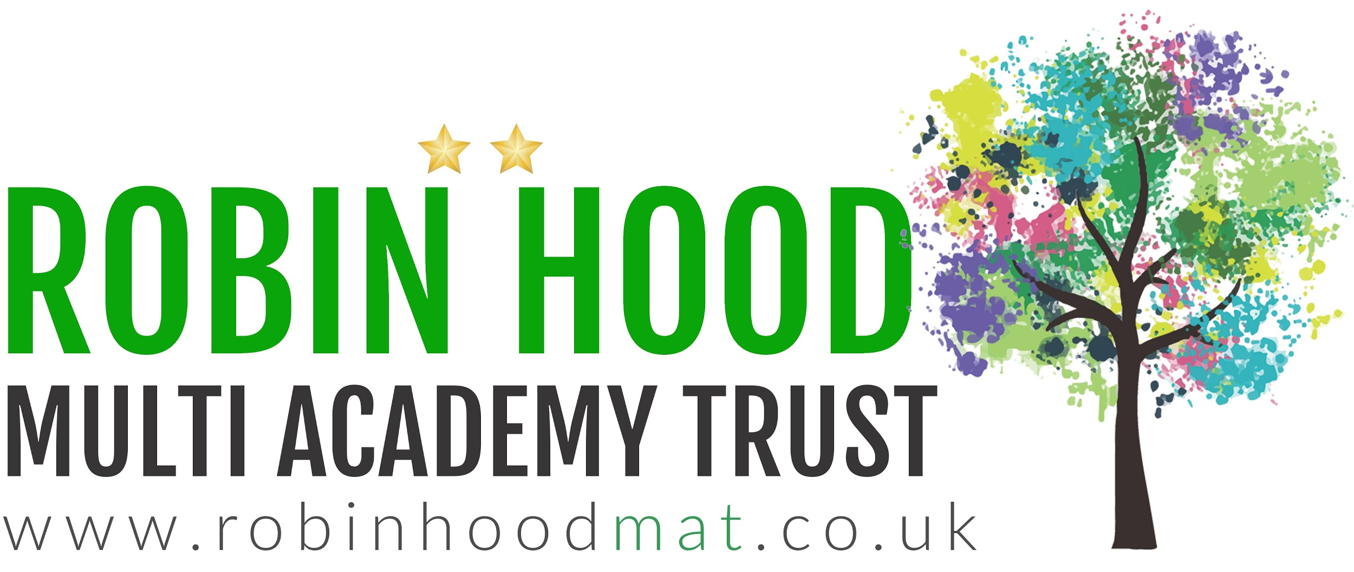
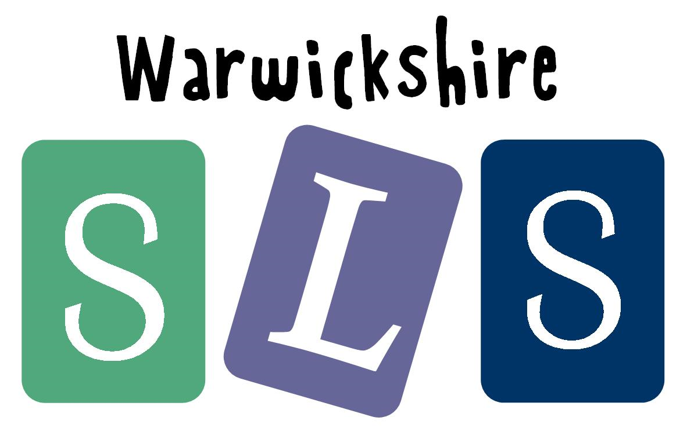
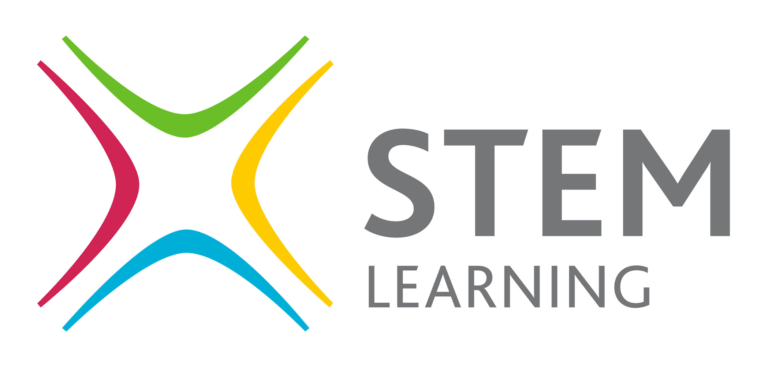
www.robinhoodMAT.co.uk

