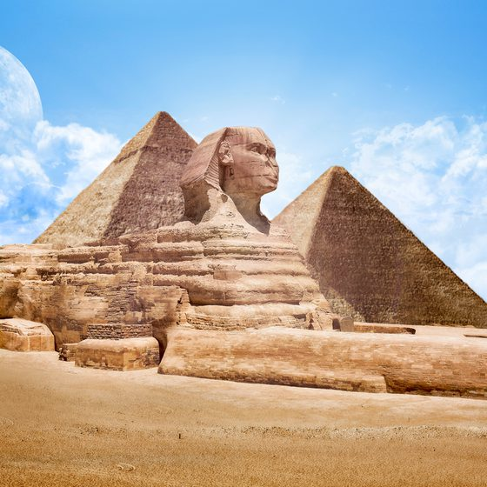

**PHSE**

Being with other people

Respect &consideration for others (kindness) Living in a Community

Equality, empathy and understanding of others (fairness)

**Art and DT** Observational drawing and painting (plants). Diary of a Country Lady – Monet Hieroglyphics Design plant holders for the gardenDrawing, painting and designing cartouches. Painting and printing siloettesClay pots Hieroglyphics

Design plant holders for the garden

Famous designers in history: Capability Brown

Artist: Andy Goldsworthy

**Science.**

Animals including humans- balanced diet, transport of water and nutrients around the body. hygiene, exercise, life cycles, skeletons and muscles.

Plants- how seeds grow into plants, what plants need to grow and the function of different parts of a plant.

**P.E.**

Swimming, games, gym and dance. Creating and evaluating sequences to music.

**Geography**

The U.K.- countries and cities. Rivers and seas. Hills and mountains. Natural resources and settlements.

**History**

Ancient Egyptions-The River Nile, the Pharoes, hyrogliphics and archeology.

**R.E.**

Islam and Hinduism- main beliefs, special places and festivals.

**English**

**Text** Flat Stanley

The Secret garden.

**Writing** Playscripts, letters, diary entries, and newspaper reports.

**SPaG** Paragraphs, suffixes, prefixes, inverted commas, past and present tense, syllables, and expanded noun phrases.

**Computing**

**Information and technology-** searching, organising, retrieving, presenting, collecting and manipulating digital content. Ongoing safety online.

**Music**

Developing an understanding of the history of music.

**Maths**

Multiplication and division

Fractions, measurement, geometry and statistics.

Class 3 Wonders of The World