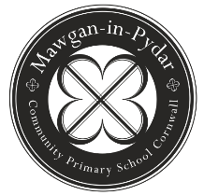
Mawgan-in-Pydar School

Dear Parents,

SCHOOL LUNCHES

Please find attached the exciting new menu from Caterlink for school meals starting in the Autumn term. Meals will start on the first day back (Tuesday 5th September) on ‘Week 1’. Please return the form on or before TUESDAY 5TH SEPTEMBER.

Children in Years R to Year 2 are entitled to a free school meal. They will be entered for a normal meal everyday each week. Please let school know if your child IS NOT going to have a meal on any specific day. If your child would only like certain meals on certain days, please let us know using the form below (place a tick in each box if you require a normal meal).

Children in Years 3 to 6. The form below can be completed and handed into reception with payment of £2.20 on a Monday morning.

If your child is a vegetarian, or prefers that option on a specific day, please put a “V” in the box.

Please see our website for the latest menu, which is on a 3 week rolling menu. The first week back after each holiday will be ‘Week 1’.

MIP School Lunch Order Form
Name of Child___________________ |  |  | Class:___
 | Menu 1 | Menu 2 | Menu 3
Monday
Tuesday
Wednesday
Thursday
Friday
Repeat for rest of term
Please:
Place a tick in each box you require a normal meal.
Mark a "v" in the box if you would like the vegetarian option.

