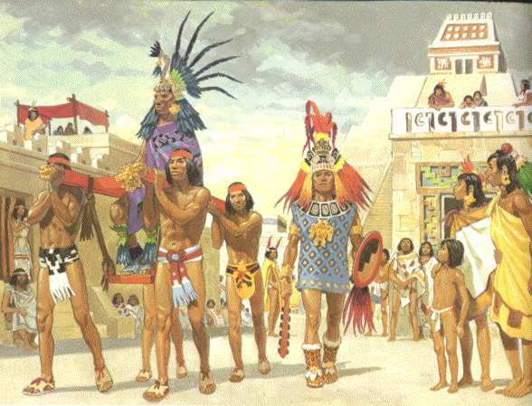

**Physical Education**

Invaders

Bootcamp

Inside out

**Modern Language**

Speaking French -describing people, places and objects.

**Geography**

Choosing places to live; learning about EU countries and planning a trip to Mexico.

**Computing**

Researching information; collecting and presenting data; making and editing films and podcasts.

**PSHE**

**Knowing me** - personal strengths and weaknesses; emotional literacy; taking responsibility; making decisions.

**Being with others** – friends; peer group pressure;

family, bullying; resolving conflict.

**Astounding Aztecs**

Class 2

Autumn 2018

**History: Aztecs**

Timelines, using artefacts to gather information; researching key events.

**Science**

**Animals including humans** – digestive system; teeth; human growth.

**States of Matter** – grouping & sorting materials; changing states; reversibility.

**Maths – Mastery**

Number

Place Value

Addition

Subtraction

Multiplication

Division

Reasoning and problem solving

**Music – Singing**

Songs for Peace Day and linked to Growth Mindset with a focus on tempo, pitch, melodic patterns and rhythmic phrases

**Design – Construction (wood)**

Designing and building a temple based on Aztec style.

**Religious Education**

Faiths: Christian, Islam, Hindu

Worshipping of gods and key festivals.

**Art**

**Collage**: using digital images.

**3D:** sculpting, studying Barbara Hepworth and replicating her style. Visit to St Ives.

**English**

**Text**: The Time travelling cat and the Aztec Sacrifice (Julia Jarman)

**Writing :** Stories, explanations and arguments.

**SPAG:** Developingsentence structures.

**Reading comprehension:** developing word knowledge, retrieving information and identifying grammatical features.

**Spelling:** Word lists from Shakespeare and more spelling Y4 – list 19; Y5; list 25

**English**